Making Visible :
Social Class in the Art of Gillian Wearing

by

Ruth White

A Research Dissertation submitted to Liverpool School of Art and Design,
Liverpool John Moores University, in partial fulfilment of the degree of
M.Res. Art and Design
September 2012

Acknowledgements

I would like to thank my mum who has always been highly supportive of my desire to be an artist and to undertake further study, despite her own lack of formal qualifications. I would also like to thank my husband Paul for his intellectual, financial and emotional support and my supervisor Colin Fallows, whose guidance and support has been invaluable.

Contents

Abstract 4
Introduction 6
Literature Review 12
Methodology 18
Chapter 1 22
The Gradual Decline of the Culture of the British Working Class: 22
British Politics, the Media and the Art of Gillian Wearing 22
Chapter 3 44
‘Fly-on-the-wall’: 44
Social Class in the Art of Gillian Wearing 44
Conclusion 55
Discussion 55
Bibliography 62
List of Illustrations 68
Illustrations 70

Abstract

The overarching aim of this thesis is to provide a wider theoretical understanding of the role that social class plays within the art of Gillian Wearing. I achieve this by drawing upon research and theories from across the social sciences; utilising her work as a vehicle to investigate the decline of working class culture and its representation within art, photography and the mass media.

The thesis is organised into three hierarchical chapters that investigate different aspects of working class culture in relation to Wearing’s art. Chapter one begins with a wide angled focus, situating her art and subjects within the English class system. The history of the working class and its gradual decline over the twentieth and twenty-first century is mapped out and significant changes in attitudes towards the working class within the political arena, the mass media, the workplace and everyday life are examined. Wearing’s practice is also contextualised within the confessional culture of 1990s and beyond, the ‘high art lite’ tendencies of the Young British Artists (YBAs) identified by Julian Stallabrass and in relation to the spectacular rise of Reality Television from 2000 onwards.
Chapter two is narrower in focus, the art of Wearing’s is located within the genealogy of the overlapping categories of realism and ‘the everyday’ used by John Robert’s in The Art of Interruption: Realism, Photography and the Everyday (1998) to map the development of photographic theories since the European revolutions in 1848. It is the ‘changing philosophic and political claims of these two categories’ as Roberts asserts which ‘underwrite so much photographic discourse in the twentieth century’ (1998:2).
Chapter three hones in on the subjects and methodology of Wearing through the application of a close sociological and philosophical reading; utilizing Pierre Bourdieu’s concepts of habitus and capital, Diane Reay’s emotional capital, and the fieldwork and insights of Simon J Charlesworth, I argue that the damaged psyches of Wearing’s subjects are a result of experiences that arise from their positions within the English class system.

Key Terms: Gillian Wearing, the English class system, the Decline of Working Class Culture, Realism and ‘the everyday’.

The denial of lower, coarse, vulgar, venal, servile – in a word, natural – enjoyment, which constitutes the sacred sphere of culture, implies an affirmation of the superiority of those who can be satisfied with the sublimated, refined, disinterested, gratuitous, distinguished pleasures forever closed to the profane. That is why art and cultural consumption are predisposed, consciously and deliberately or not, to fulfil a social function of legitimating social differences.
(Tony Bennett, 1984:XXX)

Introduction

This overarching aim of this thesis is to utilize the art of Gillian Wearing as a vehicle for investigating the English class system, the decline of working class culture and the absence of critical debates about social class within the art world. My working hypothesis is that Gillian Wearing’s subjects are class embodied subjects, whose life trajectories and traumatic experiences are a result of their positions within the English class system. Extensive research has revealed that no one has yet written explicitly about Wearing’s art in terms of class, therefore this thesis is a unique contribution to existing literature in the field.
Diane Reay a sociologist, states that ‘the contemporary orthodoxy is that class consciousness no longer exists (2005:912) and that the gender and race theorising of the 1980s and 1990s that she terms as the ‘identity turn’, very often failed to take account of the socio-economic conditions of identity and subjectivity and as a consequence ‘class as an axis of inequality’ (2011:1) has been obscured. Mike Savage observed in 2001 that in recent years there had been much sociological interest in social identity but little research on class identities (despite a long tradition of class analysis within sociology) in comparison to ‘identities of gender, sexuality, ethnicity and locale’ (2001:875). This change has also been reflected in the art world, within cultural theory and in photography through the disappearance of images of the labouring, working class body. ‘[I]n the period 1917-73 the political categories of the ‘everyday’ … were largely dominated by the labouring body and industrial culture’ with the … exception of Surrealism’ (Roberts, 1998:180) but
since the late 1970s [...] the sexualised body has come to suppress the labouring body, the dull repetitive body of the production of process and the domestic sphere. This body, with all its conspicuous unpleasureability, has practically disappeared from the debate’ (Roberts, 1998:180-181).

Gillian Wearing is an artist who has predominantly worked with subjects who are vulnerable, powerless and unable to distance themselves from their relation to the world. As David Hopkins has noted, a theme that runs throughout Wearing’s work is that of inarticulacy, this ‘experience of inarticulacy’ has been seen by Wearing as ‘foundational for her practice’ (2003:360). Inarticulacy can also be understood as a fundamental part of many working class lives, to the extent that Simon J Charlesworth devotes an entire chapter in A Phenomenology of Working Class Experience to defining ‘the barriers to articulation’ experienced by many working class people (2000:131-149) and observes that ‘silence is the huge mass that’ his text ‘circles around’ (2000:135). ‘[T]hose whose lives have been the most impoverished, […] whose lives fall, almost beyond sense, in the absurdity of an endless struggle with the ‘now’ of their lives, […] are the worst afflicted’ and it is as if ‘the contemplative condition is foreclosed upon’ by their ‘absorption in coping’ and the ‘immediate strategies of surviving’ (2000:135).
Having established the scope of my thesis, it is necessary at this point to explain some of the key philosophical and sociological concepts I apply throughout the text.
The Working Class
According to the 1998 National Statistics Socio-Economic Classification (NS-SEC) scheme, today’s working class are composed of those who carry out routine jobs such as; waiters, cleaners and couriers. Semi-routine jobs such as; cooks, bus drivers, hairdressers and shop assistants. supervisors and those whose work involves craft and related work. The majority of today’s working class can also be identified as those who are the working poor as many of the jobs listed within the NS-SEC scheme are minimum wage jobs that have to be subsided by welfare provision because they are so poorly paid.
The Under Class
The Underclass is a category within the 1998 National Statistics Socio-Economic Classification scheme applied according to sociologist Ken Roberts, to those who ‘have never worked, the long-term unemployed, and others who depend on state social security’ (2011:26).
The Middle Class
After the second world war the new middle class (as distinguished from the old middle class according to Roberts, ‘whose core members were self-employed professionals and proprietors of businesses’) increased considerably (‘it is now roughly the same size as the working class’) due to the expansion of higher education and the growing importance of paper qualifications for gaining employment. As Roberts correctly observes, ‘[m]ore and more occupations [have become] closed to non-graduates’ (2011:130-131).
Habitus and the Forms of Capital
Habitus and the forms of capital are two of the main concepts developed and used by Pierre Bourdieu to explain the different perceptions, life chances, trajectories and lifestyles of different classes and class fractions.
Habitus
a system of schemes of perception and appreciation of practices, cognitive and evaluative structures which are acquired through the lasting experience of social position.’ (Bourdieu, 1989:19)

An individual’s view of the world according to Bourdieu is ‘carried out under social constraints’ as the ‘familiar’, “taken for granted” experience of the world which is perceived through habitus ‘the mental structures’ through which we view the world, which are a result of ‘an internalization of the structures of that world.’ Therefore, ‘perceptive dispositions tend to be adjusted to position’ and ‘even the most disadvantaged’ are inclined ‘to perceive the world as natural and accept it much more readily than one might imagine’ (1989:18).
The key differences between social classes and class fractions are derived from the different volumes and compositions of the forms of capital that they each possess (1984:18). As Bourdieu states, the ‘distribution of the different classes (and class fractions) […] runs from those who are best provided with both economic and cultural capital to those who are most deprived in both respects’ (1984:108).
Cultural Capital
Bourdieu conceived of the theory of cultural capital as a means to account for the unequal academic achievements of children from different social classes and it can exist in three forms:
- Embodied capital, embodied in the ‘long-lasting dispositions of mind and body’ of individuals.

- Objectified capital, present in ‘cultural goods’ such as ‘pictures, books, dictionaries’, etc and in the ‘realization of theories or critiques of these theories’.

- Institutionalized capital is also ‘a form of objectification’ which can come in the form of ‘educational qualifications’. (Bourdieu, 1986:47)

Emotional Capital
Diane Reay expands Bourdieu’s theory of cultural capital through the concept ‘emotional capital’ in her paper A Useful Extension of Bourdieu’s Conceptual Framework?: Emotional Capital as a Way of Understanding Mothers’ Involvement in Their Children’s Education? (2000). In Reay’s terms, emotional capital is ‘the emotional resources passed on from mother to child through processes of parental involvement’ (2000:569). In chapter three I offer an in-depth analysis of Wearing’s 1997 video, 2 into 1 (Fig 1), applying Bourdieu and Reay’s theories of capitals and suggesting how all of the members of this “dysfunctional” family suffer because of a lack of emotional capital.
Abjection
Julia Kristeva developed the concept of the abject to describe ‘that which inherently disturbs conventional identity and cultural concepts’ (Childers, J/Hentzi, G,1995:1). As Kristeva states,
it is not lack of cleanliness or health that causes abjection but what disturbs identity, system, order. What does not respect borders, positions, rules. The in-between, the ambiguous, the composite’ (1984:4).
I apply the Kristeva’s theory of the abject body in chapter three to the underclass subjects of Wearing’s photographic installation work A Woman Called Theresa (1998) (Figs 2.1 and 2.2), in order to reveal how the bodies of the subjects within the photographs and the semiotics of the accompanying hand written statements may cause a feeling of abjection in its viewers, and as a result, merely reinforce negative stereotypes of Britain’s underclass prescribed by the mass media.
Texts of pleasure and texts of juissance
Text is ‘a broad term used for all human activities, products, and representations, when seen as readable’ according to Fuery and Mansfield. ‘All ‘texts’ can be deciphered as the sign of some deeper social, cultural or political reality’ (1997:215).
Although Roland Barthes’s The Pleasure of the Text (1973) is a book written about the relationship readers have to literary texts, I apply Barthes’s concept of the text of pleasure and the text of juissance to my reading of Wearing’s art, as all works of art and visual culture are texts that are read by an audience on a conscious or unconscious level.
Texts of Pleasure
A text of pleasure according to Barthes is ‘the text that contents, fills, grants euphoria; the text that comes from culture and does not break with it, it is linked to the comfortable practice of reading’ (1973:14).
Texts of Juissance
In contrast to a text of pleasure, a text of jouissance (which can be translated as bliss in the orgasmic sense of the word) is ‘the text that imposes a state of loss, the text that discomforts ... unsettles the reader’s historical, cultural, psychological assumptions, brings into crisis his relation with language’ (1973:14). I apply the concept of a text of pleasure to Wearing’s A Woman Called Theresa (1998) (Figs 2.1 and 2.2) to suggest how it does not break with the codes of the mass media (nor the codes of the art gallery) and therefore does not reveal anything of the socio-economic circumstances that have led its subjects to be they way they are. I also apply the concept of a text of juissance to Wearing’s video work 10 – 16 (1997) (Figs 3.1 and 3.2), and propose that the work unsettles the comfortable act of viewing through the technical means of synchronising children’s voices through adult bodies.

Literature Review

Sociology, Politics and the Mass Media
A Phenomenology of Working Class Experience (2000) provides one of the foundations for the research and analysis of the inner lives of the working and underclass subjects of Wearing’s art. Grounded in empirical research and interviews, Simon J Charlesworth illuminates what Reay has termed ‘the psychic landscape of class’ (2005) by relating the everyday experiences and spectacle of working class behaviour, body language, speech, attitudes and dress, to the philosophical and sociological theories of Bourdieu and Merleau-Ponty.
Ken Robert’s Class in Contemporary Britain (2011) is one of the key sociological texts I use to map out the decline of working class culture over the twentieth to twenty-first century. Owen Jones’s Chavs: The Demonization of the Working Class (2011) provides an overview of changes in attitudes towards the working class since the late 1970s within politics and the media. The historian David Kynaston has observed that from around the 1980s onwards it became acceptable in the media to ‘disparage the working class … in a disrespectful and wholly unkind way’ (Kynaston in Jones, 2011:111);
Reality TV shows, sketch shows, talk shows, even films have emerged dedicated to ridicule working-class Britain. ‘Chavtainment’ has reinforced the mainstream view of working-class individuals as bigoted, slothful, aggressive people who cannot look after themselves, let alone their children’ (Jones, 2011:122).
Numerous examples of the denigration of the working-class in the media are given by Jones, such as the Sun newspaper’s reporting of the Hillsborough disaster based upon ‘lies circulated by the police (2011:69), the ‘avalanche of hatred’ directed towards the reality television celebrity Jade Goody (2011:123) the attitude of the media towards the disappearances of the child of middle class parents, Madeleine McCann, for which British journalists ‘penned 1,148 stories [after a fortnight and] the sum of £2.6 million [was] offered as a reward’ for her return, in contrast with the attitude towards the lower class parents of Shannon Mathews (although it later came out that the mother of Shannon Mathews had set the whole thing up) when after two weeks, ‘the case had received a third of the media coverage given to McCann in the same period’ and the ‘relatively paltry sum of £25,500 [which rose later to £50,000] was offered for her return (Jones 2011: 13-14). Jones maps out the attitudes of successive governments towards the working class since the advent of Thatcherism. As Jones correctly observes,
‘[t]here is an insidious side to the pretence that class no longer exists in modern Britain. Rarely a day goes by without some politician or commentator paying homage to a ‘meritocracy’, or the idea that anyone with talent and drive can make it big in modern Britain. The tragic irony is that the myth of the classless society gained ground just as society became more rigged in favour of the middle class’ (Jones, 2011:167).
Although not referred to within the body of this thesis, John Hill’s Sex, Class and Realism: British cinema, 1956-1963 (1986) is an important text for understanding the history of working class representation in the media. Films such as Karel Reisz’s, Saturday Night and Sunday Morning (1960) and Tony Richardson’s The Loneliness of the Long Distance Runner (1962), both of which were based upon stories written by Alan Sillitoe, are important historical documents; not only because they depict the factories, neighbourhoods and lifestyles of the working class and a way of life that is no longer with us, but also because they reflect a more sympathetic and romantic attitude once held by those working in documentary, film and television. The early documentaries of Nick Broomfield are equally significant. For Behind the Rent Strike (1975) Broomfield interviewed and followed the lives of the working class inhabitants of tower blocks in Kirkby, a socially deprived area of Liverpool (the place where my mother spent her teenage years). What comes across strongly within the film is the strength of political feeling and organisation of those involved in the strike which contrasts starkly with the disempowered working class and underclass of Britain today.
Art and Photographic History, Theory and Criticism
One of the most important texts for understanding the significant role that photography has played in the representation of the working class is John Roberts The Art of Interruption: Realism, Photography and the Everyday (1998). Roberts maps out the history and development of photographic theories ‘through the overlapping categories of ‘realism; and the ‘everyday’ (1998:2) and reconnects ‘photography to a social history of the avant-garde’ (1998:4) both of which support his argument that the ‘explicit connection between photography, reason and class-consciousness may have been lost or become muted’ (1998:2).The connection that Roberts’ observes that the artists Jo Spence and Jeff Wall have with the aims of the early avant garde and to raising class consciousness, is something I do not refer to directly in the body of the thesis, but the theories and practice of both artists is something I have investigated and will continue to investigate further in my PhD.
Julian Stallabrass’s (2006) High Art Lite: The Rise and Fall of Young British Art (revised in expanded) is one of the few texts written about the art of the 1990s and how it was critically received. Stallabrass (2006:2) uses the term ‘high art lite’ to describe ‘the idea of a fast food version of the less digestible art that preceded it’. Important to my analysis is to consider how Wearing’s art engages with mass culture. Stallabrass charges the young British Artists (yBas) with whom Wearing has been associated with in the early 1990s as having;
[A]ped the forms of mass culture in a manner that allows viewers both to enjoy the acts of expropriation and exploitation, and to justify them on the dubious grounds that they raise awareness of cultural degradation. (Stallabrass 2006:308)
The class positions of the subjects in Wearing’s art works are central to this thesis, but I it is also vital to consider the class positions of the audience of her art works in order to ask, who is she making her work for? Stallabrass (2006: 301-302) suggests that ‘until the 1990s’ Britain’s university system had been restricted to an elite few, many of which had been to private schools, around ‘15 per cent in 1989’. The rise in the popularity of art in Britain is not only is associated with YBAs who created interest in art in the 1990s, but also with the rising numbers of those attending university, which by ‘1993-94’ was around ‘30 per cent’. Stallabrass cites Bourdieu’s writing ‘on the social character of gallery-goers’ and observes that the ‘correlation between higher education and the propensity to visit galleries, still holds.’ Stallabrass (2006:302) also notes that the working class, ‘as it used to be understood’, ‘is still almost entirely excluded from art-world audiences, despite concerted attempts to diversify the gallery audience.’ Many of the essays I have read about Wearing are complementary and only acknowledge some of the ethical problems inherent in her art in order to defend against accusations of exploitation.
‘High art lite’ and the Young British Artists played a small part in the art world of the nineties but are perhaps the most famous; Michael Bracewell’s The Nineties: When Surface Was Depth (2002) allows me to situate the art of Wearing within the confessional culture of the nineteen nineties, his observations on all areas of cultural life in Britain in the 1990s demonstrates how the tendencies of the ‘high art lite’ generation are a part of wider cultural tendencies. In Right About Now: Art and Theory Since the 1990s (2007) Rakier and Schavemakerm identify some of the key themes written about by significant theorists during that period which I refer to in more detail in chapter two.
David Hopkins’s ‘Out of it’: Drunkenness and Ethics in Martha Rosler and Gillian Wearing (2003), provides one of the few texts I have come across that is highly critical of Wearing’s art yet also suggests that ‘it may offer new resources of representation’ (2003:341). Significant for understanding the historical positions of Wearing’s subjects is Hopkins’s acknowledgement of the ‘metaphorical and physical relocation of the British working class’ in the 1980s and early 1990s, together with the significance of the introduction in Britain and the USA of “care in the community” which resulted in ‘many instances of alcoholism’ as a response to those with mental illness being ‘forced to cope with urban survival.’ He also makes a link between Wearing’s ‘inarticulacy’ growing up in ‘a working-class environment in Birmingham’ and the drunks in her video and suggests that, ‘there is a sense in which the social dysfunctionality and befuddlement of her drunks stand for a wider voicelessness’ (Hopkins, 2003:360). ‘Out of it’, also provides a direct comparison between the representational strategies and ethics of Rosler’s The Bowery in Two Inadequate Descriptive Systems (1974) and those of artists in the 1980s and 1990s, by posing the representational strategies of Wearing’s work Drunk in opposition.
Although not referred to in the main body of this thesis, Jay Prosser’s Ph/autography and the Art of Life: Gillian Wearing’s Ethical Realism, is the another key text that I have used for examining the ethics within Wearing’s art. Prosser is far less critical of her methods and proposes that her work is an example of ‘ethical realism in contemporary art’ (2002:193). He writes that Wearing has made ‘a move from the performative self [which as he writes, are found in the work of Orlan and Cindy Sherman] to the other’ therefore her work ‘exemplifies a move from the fabrication of trauma in the wounded body to the recording of the existent trauma in the body politic’ (2002: 201).
Similarly, Hal Foster’s Return of the Real (1999) has not been directly referred to within the main body of the thesis, but has enabled me to situate Wearing’s art within the genealogy of art of the twentieth century. A considerable amount of Wearing’s oeuvre deals with trauma, Foster (1999:166) examines the ‘contemporary concern with trauma and abjection’ mapping out the changes in art from the 1970s up to the late 1990s, writing that many artists of the 1990s not only wanted to separate themselves from ‘the textualist model of the 1970s’, but also from ‘the conventionalist cynicism of the 1980s’. They did so either by taking ‘cynical reason to an extreme’, challenging ‘cynicism with abjection’, or by challenging ‘cynical reason’, turning ‘from the involution of art-world endgames to the extroversion of quasi-ethnographic fieldwork.’ Consideration of Wearing’s ethnographic methods is of paramount importance to any study of her work, Foster maps out what prompted the ‘ethnographic turn in contemporary art’ (1999:184) through surrealism, art brut, abstract expressionism and ‘variously in art in the 1960s and 1970s’ (1999:181-182) and notes the ‘shift from a subject defined in terms of economic relation to one defined in terms of cultural identity (1999:173). Wearing’s methods are reflexive as she allows her subjects a voice either through audio or written methods, Foster notes that reflexivity ‘can disturb automatic assumptions about subject-positions, but it can also promote a masquerade of this disturbance: a vogue for traumatic confessional in theory that is sometimes sensibility criticism come again’ (1999:180).

Methodology

My overall method of inquiry for this thesis is qualitative, in the form of a case study of not only Wearing’s oeuvre as a whole but of individual works which I have interpreted using critical theory, drawing upon knowledge from across the social sciences and humanities. More specifically, this interpretation includes a sociological and philosophical analysis of the transcriptions of the interviews of her subjects that provided the sound track for the video projection, 10 – 16 (1997) (Figs 3.1 and 3.2) the video, 2 into 1 (1997) (Fig 1), and the hand written text panels of the subjects that feature in A Woman Called Theresa.(1998) (Figs 2.1 and 2.2).
Following on from my reading of John Hill’s Sex Class and Realism: British Cinema 1956-1963 (1986), I viewed a number of videos, documentaries and films that relate to my research. During my investigation I discovered the recent addition of Paul Watson’s 1974 twelve part fly-on-the-wall documentary series, The Family (one of Wearing’s key influences) to the internet site You Tube and was able to view all twelve parts and the follow up programme with Watson’s subjects in 1984. I was also able to view Michael Apted’s entire Up documentary series (1964 onwards) (Wearing’s other main influence) on You Tube and was fortunate to be able to view the latest episode broadcast in May this year of interviews with Apted’s subjects at the age of 56. Both documentaries are crucial for understanding the influence they had on Wearing’s art but also for the historical value both programmes have for documenting changes in working class culture and the representation of the working class since the 1960s. I also viewed Alan Bleasdale’s drama, Boys From the Blackstuff (1982), the early documentaries of Nick Broomfield and the Liverpool soap opera, Brookside’s Bobby Grant’s trade union speech on You Tube (1987). I have embedded my documentary and film research on a blog I began three years ago, under the category of social class: http://artistresearcher.wordpress.com/.
Parallel to my analysis of class, which Foster would term the ‘horizontal axis or social dimension’ (1999:xi) it is important that I pay attention to the ‘vertical axis or historical dimension’ (1999:xi) of Wearing’s art. Although not referred to at any length within the main body of the thesis, Hal Foster’s Return of The Real has informed my understanding of the ‘crucial shifts in Western conceptions of the individual subject and the cultural other’ (1999:208), the history of critical theory within twentieth-century art which Foster terms as ‘a secret continuation of modernism by other means’ (1999:xiv) and the many ‘turns in critical models and returns of historical practices’ (1999:x) that have taken place.
As already noted, Wearing’s two main influences are Michael Apted’s, longitudinal, intermittent, documentary Up series (1964) (Fig 4) for which he has tracked the lives of fourteen individuals from a range of socio-economic backgrounds from the age of 7 up to 56 in 2012. Apted went in to his project with ‘a very polemical purpose [in order to make] a point about class’ (Apted, 2005) and Paul Watson’s twelve part fly-on-the-wall documentary series The Family (1974) (Fig 5) (considered by many as the precursor for reality television) about the day to day lives of a working class family from Reading. I will discuss the ideology and methodology of both series in order to make a direct comparison with Wearing’s practice and consider if Wearing’s methods give her subjects more or less control over how they are represented. I also consider how documentary making has changed since the rise of reality TV and reflect on its implications for Wearing’s practice and for artists in general.
A crucial point about Wearing’s oeuvre as a whole which is quite often overlooked is the fact that for many of her art works Wearing engages in what could be described as quasi-psychoanalytical methods. It is therefore important to consider the ethical implications of artists working with vulnerable subjects.

Chapter 1

The Gradual Decline of the Culture of the British Working Class:

British Politics, the Media and the Art of Gillian Wearing

Gillian Wearing is a British artist who was brought up in Birmingham in the 1960s and 70s. In the early 1990s she rose to prominence within the art world with a group of graduates from Goldsmith’s College who became known as the young British artists (YBAs). It has been well documented that Wearing’s main influences are Paul Watson’s The Family (1974) (Fig 5) and Michel Apted’s Up (1964 – 2012) (Fig 4). Both documentary series are overtly about social class; The Family is centred around observation of the day-to-day lives of a working class family from Reading and the Up series has followed the lives of a group of individuals from a range of socio-economic backgrounds since the age of seven and is based upon the premise that the trajectory of their lives would be determined by their positions within the English class system. Extensive research of texts written about Wearing and her art and interviews with her reveal that she has not discussed the Up or The Family documentary series in terms of class, nor has she discussed her own work in these terms, but I would argue that class plays a considerable role within her oeuvre. For example her two year project with a group of London street drinkers which resulted in the works A Woman Called Theresa (1998) (Figs 2.1 and 2.2), Drunk (1999) (Fig 6) and Prelude (2000) (Fig 7) and are undeniably about the lives of individuals from Britain’s ‘underclass’. The underclass have become an increasing feature of British society since the 1970s due to ‘the level of unemployment, and the extent to which social security benefits have dropped further and further behind average earnings’ (2011:26). 2 into 1 (Fig 1) is undeniably about a middle class family where the status gained through cultural and education capital is paramount, which I discuss in more detail in chapter three. The growth of the middle class has increased competition for jobs and in turn the pressure for middle class children to do well in education in order that they do not become downwardly mobile. As Roberts correctly observes;
Downward mobility from the middle class is sufficiently common to be perceived as a very real threat. Hence the concern of middle class parents to reduce the risks – to do almost anything that might achieve this (see Devine, 2004; Walkerdine et al, 2001). (Roberts, 2011:188)
In 10 – 16 (Fig 3.1 and 3.2) individuals from markedly different socio-economic backgrounds reveal their life experiences, ranging from the experience of an aggressive, unkempt child from an underclass background with very little economic and cultural capital in stark contrast with a contented middle class child in possession of a relatively large amount of economic and cultural capital which I examine in more detail in chapter three.
In order to map the decline of working class culture and the changes in attitude that have occurred particularly within the media, the political arena and the art world, I deem it necessary to give a brief outline of its history.
The formation of the working class began in the nineteenth century when Britain became the world’s first industrial nation (Ken Roberts, 2011:80). Workers spent time together not only at work but also during their leisure time. Friendships and camaraderie were a result of the working class having to rely on each other in quite often dangerous working conditions and from workers needing to be housed in the same neighbourhoods close to their place of work before public transport was introduced; even after the introduction of public transport, this continued to be the case. Leisure for working class men was centred on a mixture of ‘clubs, pubs, beer, football, chapel, brass bands, pigeons’ depending upon place. For the most part, working class women’s lives were confined to their homes and neighbourhoods looking after children and doing domestic chores.
Everywhere there was a distinction between respectable and the rough. […] All the industrial cities had rough areas, usually where the most recent migrants settled, which were renowned for the residents’ irregular work habits, their criminality, the gangs, and the street fights after closing time at weekends’ (Roberts, 2011:81-82).
The distinction between respectable and rough sections of the working class still exists today. My research suggests that many of Britain’s working class poor who sell their labour for a minimum wage resent those who appear to better off unemployed and on benefits and this has been used to the advantage of politicians and the media in the last thirty years to demonise large sections of the working class community and justify cuts in welfare provision.
Sociologists only began studying the working class in detail in the 1950s when ‘it was believed (correctly as it has turned out) to be changing in fundamental ways’. This fundamental change according to ‘most commentators [political scientists and journalists] in the 1950s and 60s’ was ‘embourgeoisement […] in the context of full employment, steady economic growth and regular pay rises that had been maintained since the Second World War (Roberts, 2011:83-84).
Goods and services formerly associated with the middle-classes – soft home furnishings, television sets, washing machines, motor cars and holidays abroad – were being enjoyed by more and more working class families. (Roberts, 2011:84)
In the 1960s the increase of ownership of televisions and cars could be said to be one of the major catalysts for the changes that occurred within working class culture alongside the increase of women in employment and in turn the loss of a sense of community and solidarity. As Robert’s writes, ‘neighbourhood life was collapsing throughout the length and breadth of the country […] television was keeping people ‘in’, while the motor car was enabling them to go out in private’ (Roberts, 2011:86). Even today, researchers have observed that the lifestyle of the contemporary working class is ‘more uniform [than the middle class], and more TV-dominated’ (Roberts, 2011:145). Another significant change has been the ‘disorganisation’ of the working class which ‘has declined drastically as a cultural political force’ (Roberts, 2011:15) due to not only the reasons given above but also because of
the steep contraction in manufacturing employment, the shift of employment from large to small establishments, […] higher absolute rates of upward mobility, the spread of unemployment and precarious jobs, and manual workers becoming more mixed in gender and ethnicity.[…] and the loss of ‘its former organizations – trade unions and the Labour Party’ (Roberts, 2011:15).
The beginnings of a significant change in attitude to welfare provision, unemployment and the working class within politics and the mass media can be traced back to Margaret Thatcher’s appointment as prime minister in 1979, which in the words of Owen Jones, author of Chavs: The Demonization of the Working Class (2011);
marked the beginning of an all-out assault on the pillars of working-class Britain. Its institutions, like trade unions and council housing, were dismantled; its industries, from manufacturing to mining, were trashed; its communities were, in some cases shattered, never to recover; and its values, like solidarity and collective aspiration, were swept away in favour of rugged individualism. (Jones, 2011:10)
The sociologist Simon J Charlesworth has noted the ‘decline of the culture of the working class’ since the early 1980s and how the working class, ‘for whom the economically marginal and socially excluded are family members and neighbours […] have had to deal in the most palpable way with the decline of their own economic role and social position’ (1998:2). The miners’ strike in 1984-1985 signalled the demise of the power of the trade unions and as a consequence had a major impact on the rest of the labour movement. As Jones asserts, ‘the defeat was a crippling blow from which it never recovered. The miners had been the strongest unionised force in the country: if they could be routed, what hope for anyone else?’ (Jones 2011:58). The destruction of the ‘old industries associated with working-class-identity’ now meant that ‘[t]here no longer seemed anything to celebrate about being working class’ (Jones, 2011:60).
In the 1980s within the media, the sympathetic if not romanticised portrayal of ‘likeable working-class characters’ in television programmes such as ‘Only Fools and Horses and Auf Wiedersehen Pet’ began to shift in the early 1990s when comedian Harry Enfield’s brought his characters Wayne and Waynetta Slob to the collective imaginary. I distinctly remember Wayne and Waynetta Slob, who were depicted as benefit dependant, unhygienic, chain smoking, junk food eating, irresponsible parents. Jones observes that ‘[e]ven today, the media enthusiastically use Waynetta Slob as a template when attacking groups of working-class people’ (2011:110-111). The comedic successor to Enfield’s Waynetta Slob could be said to have arrived in 2003 in the form of Vicki Pollard, a grotesque character in the comedy sketch show Little Britain. Pollard is a white, teenage, single mother, who wears a track suit, is inarticulate, sexually promiscuous, unhealthy, and has a bad attitude.
In the 1980s Phil Redmond’s Brookside was one of the few soap operas that dealt with the politics of everyday life for working class people in Britain. His character Bobby Grant was a trade union shop steward involved in industrial action which reflected the political unrest in Britain at that time (1982). Over time Brookside lost its political edge and focused upon individual rather than collective dramas such as incest, rape, breast cancer and homosexuality. Alan Bleasdale’s five episode drama Boys from the Blackstuff (1982) was even more politically charged as it followed the individual lives of a group of unemployed Liverpool men who had previously worked together laying tarmac ‘struggling with unemployment, poverty and desperation in a city going to waste under harsh Thatcherite economic policies’ (Reid, 2003-12). Indeed Boys from the Blackstuff is so overtly political that characters were given monologues by Bleasdale that made reference to Marxism.
In the 1990s, Charlesworth carried out empirical research in Rotherham an old industrial area of Britain and found that what emerged from his interviews with its inhabitants was ‘a remarkable coherent story of the loss of a way of living’. A way of living ‘that was based upon hard work and industry, within which there was a sense of friendship and relation, of basic dignity and respect’ and how ‘the decline of traditional industry’ and the introduction of new types of jobs (part time and badly paid) have led to a misery that affects most areas of their existences, through a lack of ‘companionship’ and job insecurity (Charlesworth 1998:10). In the 1980s the British working-class was divided by the introduction of Thatcher’s ‘right-to-buy’ scheme that allowed council tenants to buy their own homes at a reduced price, thus creating a separation between those who could afford to become home owners and those who remained council tenants. By the 1980s council estates gained their negative reputation as being run down and riddled with crime and poverty due to the fact that those who remained as or became council tenants were amongst the poorest and most disadvantaged in society (Jones, 2011:61-62).
In the 1990s the working class could no longer rely on the Labour Party to represent its interests, the working class ‘no longer comprised the majority of voters’ and ‘the leadership made it clear that it did not wish to be associated with any particular class’ (Roberts, 2011:94). As Martin Pugh states in Speak for Britain!: A New History of the Labour Party, ‘[Tony] Blair’s emergence was symptomatic of the extent to which the Labour Party had been shredded by Thatcherism ideologically and institutionally’ (2010:387).
In 2003, with the rise of the Internet came the website ‘ChavScum’ with its tagline, ‘Britain’s peasant underclass that is taking over our towns and cities’ (Jones 2011:112). As Rogaly and Taylor state, the ‘chav’ and ‘white trash stereotypes are ‘used as short-hand … to describe and write off vast sections of Britain’s population – often white, often living on council estates and nearly always poor’ as well as signifying particular ways of dressing, speaking, ‘educational aspirations’, ‘patterns of family behaviour’ and ‘involvement with welfare and social control agencies’ (2009:3).
In the summer of 2000 the reality television series Big Brother first came to our screens. Since its huge success there has been a vast amount of reality TV programmes produced, many of which centre around the events and behaviour of the lives of working class subjects but most of which fail point to the socio-economic conditions of their lives. Programmes such as The Jeremy Kyle Show which began in 2005 and is still highly successful (expanded to the USA in 2011), concretise the stereotype of the lower classes through the confessions of its guests who reveal lives of chaos and impoverishment. They are blamed by the host for their lack of morality and failure to become upwardly mobile; the economic and material realities of their positions which have clearly impacted on every aspect of their lives are ignored.
Michael Bracewell surveyed 1990s British culture in his book The Nineties: When Surface Was Depth (2002) the title of which also reflects the ‘high art lite’ tendencies of the YBA’s that Stallabrass wrote about at the end of the 1990s of which I will refer to later in this chapter. Many of the key ideas of the 1990s that Bracewell lists are reflected within the art of Wearing, much of which is centred upon the trauma and confessions of others, and within the art of Tracey Emin who obsessively reworks her own personal traumas for public consumption:
- ‘Brute Authenticity would replace Brute Irony as the temper of the zeitgeist’.
- ‘In the 1990s, the cross-cultural pursuit of Authenticity would also provide the ‘bread and circuses’ (most importantly, Popular Factual Programming – ‘reality’ and ‘conflict’ TV – and obsession with ‘celebrity’ and confessional journalism) with which to distract the near civic panic during the petrol shortages) of consumer society.’
- ‘This obsession with Authenticity would declare realism to be synonymous with dysfunctionalism.’(Bracewell, 2002:21-22).

Although Reality Television was in it’s infancy in the early 1990s when Wearing was developing as an artist, it becomes clear that the nature of Wearing’s art in many ways reflects the ‘temper of the zeitgeist’ of the 1990s that Bracewell has drawn attention to because of the central role that confession plays within her work. Although it must be said that this temper is not solely the product of the last thirty years as both the Up series (Fig 4) and The Family (Fig 5) which I have previously referred to as Wearing’s main artistic influences, both contain the same mixture of authenticity and confession that have been identified with media in the 1990s and in particular Reality Television. For example in The Family (Fig 5) which aired in 1974, the matriarch of the household Margaret Wilkins revealed that her youngest son was the result of an affair. In the Up series (Fig 4) Tony in 42UP which aired in 1998 revealed that he had been unfaithful to his wife. The key difference between the participants of The Family and Up (apart from the later episodes of the Up series when its subjects became more aware of how they were being represented through how the shows were edited) and Reality Television is that the participants of Reality Television are far more media savvy so that the authenticity they demonstrate and the techniques used by production teams to falsely create drama’s may be considered as less authentic.
Michael Bracewell has also noted the confessional nature of much of the art and media of the 1990s,
[A]cross the temper of the times, the ‘ever hidden wound’ was being exposed, and made public. […]rather than undergoing the translation into a Flaubertian – or even Warholian) model of art and creativity, in which the presence of the artist was converted wholly into art itself, the wound was being offered up, raw and direct, as a kind of celebration or cult of actuality in relation to the personal. (Bracewell, 2002: 71-72)
Works by Wearing such as Confess All On Video Don’t Worry, You Will Be In Disguise. Intrigued? Call Gillian… (1994) (Fig 8.1 and 8.2), Trauma (2000) (Fig 9), and Secret’s and Lies (2009) (Fig 10) are all based purely on the confessions of individuals and the only intervention by the artist appears to be the masks worn by all of her subjects (with the exception of a transsexual male in one work) to protect their identities. Other works such as Prelude (2000) (Fig 7), Brian (1996) (Fig 11), 2 into 1 (1997) (Fig 1), 10 -16 (1997) (Figs 3.1 and 3.2) A Woman Called Teresa (1998) (Figs 2.1 and 2.2) ( Bully (2010) (Fig 12) and one of her most ambitious works, the documentary film Self Made (2010) (Fig 13) are also confessional because of the way that in one form or another the subjects reveal their inner thoughts and/or private lives.
Julian Stallabrass states that amongst the work of the young British artists (which includes Wearing), there is ‘no common programme […] no manifestos, no group statements, no shared style’, but there are some ‘distinguishing characteristics’ which he identifies as; its ‘overtly contemporary flavour […] apparently breaking with the provincial air of much previous British work’, the ‘distinctive relationship’ the artists have ‘to the mass media and their frequent use of ‘material drawn from mass culture’ and the presentation of ‘conceptual work in a visually accessible and spectacular form’ (Stallabrass, 2006:4).
As John Welchman states
[T]he YBAs took refuge in images that solicited the spectacular, the monstrous, the hyper-subjective, or trawled in the off-beat margins of the suburban everyday. The domain of appropriated objects and signs is not engaged for the purposes of critique,[…] Appropriated objects, substances and persons have two destinies in this work. They become curios or extravagances […] or they become aligned with that ‘ventriloquising [of] the amateur and the “incompetent”’ that serves the YBAs ‘as a means of resisting and subverting what they see as the professionally overdetermined protocols of critical postmodernism’. But ‘the new art’s appropriation of amateurism’ results only in collapse in the distinction between ‘the aesthetic subject and the consumer of popular culture’.(Welchman, 2001:36-39)
Stallabrass proposes that the increased popularity of contemporary art that accompanied the rise of the YBAs was a result of not only the huge increase the amount of people attending university from the early 1990s onwards (2006: 301-302) but also the private art market going into ‘prolonged hibernation during the recession that began in 1989’. The recession he suggests is also linked with two important changes that happened in the period 1989-91 which also fed into ‘high art lite’; the first being Charles Saatchi’s disposal of his ‘collection of blue-chip British, US and European art’ and subsequent collecting the work of young British artists. The second being the bankruptcy of the sponsor of the Tate Gallery’s Turner Prize which resulted in a change in direction towards the work of younger artists (Stallabrass, 2006:5).
Parallel to the ‘high art lite’ tendency critiqued by Julian Stallabrass in High Art Lite: British Art in the 1990s (1999) there were many other developments within the art world. Six key themes have been identified by the writers of Right About Now: Art and Theory Since the 1990s (2007) to represent ‘important aspects’ of art since the 1990s which reflect the critical analysis applied by significant theorists during that period. The themes selected were:
- The Body as ‘it has been widely studied’.
- Interactivity as it is considered as ‘one of the few “new” trends in the 1990s, both in terms of the digital revolution and in the field of art.’
- Engagement (‘opportunities and restrictions’) which Schavemaker and Rakier suggest have become more pertinent since 9/11.
- Documentary strategies, ‘[h]ow is photography used? And how does photographic truth compare with fiction?’
- Money because the ‘collapse of the art market in 1990 is usually described as the end of the “postmodern” era and the beginning of new “post-postmodern” developments.’
- Curating as ‘it was not so much the museums that defined the image but rather (star) curators – most of them not formerly associated with institutions – who presented the temporary, context-bound art of the 1990s at location often outside the official museum circuit.’ (Schavemaker and Rakier, 2007:10-11)
Like many observers, Schavemaker and Rakier have also noted the lack of ‘theoretical reflection or historical contextualisation’ since the 1990s, in stark contrast to previous decades (2007:9). They make reference to John Welchman’s argument that ‘the art of the 1990s no longer referred to other art or great theories, and hence did not constantly invite intellectual reflection’ and that in the 1990s, ‘it seems, it was the art itself, and the experience it provided, that were key’ (Schavemaker and Rakier, 2007:10).
Summary
My findings demonstrate that since the 1970s there has been a steep decline in working class culture as a result of not only of the demise of traditional working class jobs and the power of trade unions, mass unemployment, job insecurity, changes in the sorts of jobs working class people do, amount of wages they earn, dependency upon state welfare, but also in the attitude the working class has towards themselves (being working class is no longer something to be proud of and younger generations have no memory of what has been lost) and in the political arena where aspiring to be middle class is encouraged and a sort of class racism towards the welfare dependant underclass is acceptable. All of this has been accompanied by not only a de-politicisation of television programmes since the early 1980s that are explicitly about working class struggles but also a de-politicisation in the art world which has been reflected in the ‘high art lite’ tendencies of the YBA generation since the late 1980s, all of whom to my knowledge have not referred to, or had their work critiqued explicitly in terms of class (the exception being Stallabrass and his discussion about the Urban Pastoral in High Art Lite), despite the tendency of many of the YBAs to work with, depict or refer to those from the working class or under class. Although the centrality of confession within the art of Gillian Wearing (and Tracey Emin) reflects a wider cultural trend of the 1990s and beyond, it is also a fundamental part of the two documentary series from the 1960s and 1970s that Wearing acknowledges as her primary influences.
The origins of documentary television and the depiction of working class lives on screen are something I explore in my next chapter through the relation of Wearing’s art to the categories of realism and ‘the everyday’.

Chapter 2
Gillian Wearing:
Realism and the ‘Everyday’
Within this chapter I propose that Gillian Wearing’s art can be situated within the overlapping categories of realism and ‘the everyday’ that John Roberts uses as a framework for his text, The Art of Interruption: Realism, Photography and the Everyday (1998). Roberts proposes that the categories of ‘realism’ and the ‘everyday’ ‘overwhelmingly capture the political and utopian content of early photography’,
[F]or the avant-gardist and social documentarists alike photography’s naturalistic powers of definition and historical ‘recall’ were viewed as being on the side of emancipation and reason. (Roberts, 1998:2)
Much of Roberts’ thesis is devoted to a defence of ‘the dialogic and communicative functions of photography against its aesthetic and psychoanalytical critics’ (1998:4). The ‘theoretical attack since the 1970s on photographic naturalism as positivist’ he writes, has made it ‘difficult to retain the intimate connections between the avant-garde and the realist, reportorial ambitions of documentary culture’ (1998:3).
Of particular importance to my thesis is to highlight the important role that photography has played in the representation of the working class;
Notions such as ‘making visible’, the ‘memory of the working class’, ‘historical consciousness’ and ‘counter knowledge’ are part of a shared commitment to what are perceived as the ‘truth-telling’ powers of photography’ (Roberts, 1998:3).
Realism as a category can be used to ‘make distinctions between various kinds of image production’. The effect of realism can be produced by works that deliberately make apparent ‘the contradictions out of which it makes its meanings’. Documentary photographs that demystify or counter the prejudice of ‘certain states of affairs’ can also be said to ‘produce realist effects’. In both cases, ‘the claims to such effects will be discursively constructed’ and will be ‘subject to change and revision given changes in contextual circumstances’ (Roberts, 1998:12).
The foregrounding of the construction of the documentary form of many of Wearing’s video and photographic installations make it apparent how her oeuvre fits within the category of realism according to Roberts’ definition. The construction of the art works are revealed or draw attention to themselves through technical devices such as lip synching in video works such as 10-16 (Figs 3.1 and 3.2), 2 into 1 (Fig 1) and Prelude (Fig 7), through the depiction of Wearing pressing the camera shutter that triggered the production of the image in the photographs for Take Your Top Off (Fig 14), through the handwritten signs that declare the thoughts of, and were made by, the subjects holding them in the photographs for Signs That Say What You Want Them To Say and Not Signs That Say What Someone Else Wants You To Say (Fig 15) , its title also points to the history of documentary critique, and the two screen video installation Family History (2000) (Figs 16.1 - 16.3) where the set of a TV studio and living room installation used for filming the work is revealed to the audience at the end of the video, not only drawing attention to the construction of the work but also to the construction of television and chat shows in general and how they are consumed by people within their homes.
Roberts says of the ‘everyday’ and ‘realism’ that the ‘explicit connection between photography, reason and class-consciousness may have been lost or become muted’(1998:2), it could be said of the art of Wearing that this explicit connection is muted through her failure to refer to the outer societal causes of most of her subjects troubled lives. Her works could also be described as urban pastoral. ‘Pastoral is plainly ‘an art that is about common people but not for or by them’ (Stallabrass, 2006:251), due to the fact the works have only been displayed within a gallery setting (apart from Family History which was temporarily installed in two apartments in Birmingham and Reading and Self Made which was shown in selected art house cinemas) and exclude the majority of working class people who have not been through higher education (including many of those who have taken part in the works and particularly the street drinkers in several of her works), proven by the research and statistics of Bourdieu and Stallabrass to rarely visit art galleries (Stallabrass, 2006:179). In other words, the work can only be for the consumption of the more privileged and educated middle and upper classes. For Wearing’s art to be truly democratic her work would need to be televised or available on the internet as an artist such as Mark Leckey has chosen to do (Leckey has a channel on You Tube where many of his works can be found).
According to Roberts, the category of ‘everyday’ and ‘Modernism’ (a less contentious description of the everyday, suggesting the ‘new’) began in France after ‘the 1848 revolutions and the rise of the industrial bourgeoisie and the new workers movement’ with Manet. In a break with the history painting and French salon system of the time, he not only chose to depict subjects of the ‘everyday’ and the ‘ordinary’ but also carried it through in his working processes; ‘workmanlike, honest toil’, ‘rough painterly surfaces’ and ‘flattened space’ (1998:14-15).
In the early part of the twentieth century as a consequence of ‘rapid industrialization, the deepening crisis of classical culture, the success of the Russian Revolution [and] the opening up of the hidden world of sexuality through psychoanalysis’, the term ‘the everyday’ entered into ‘the sphere of politics, science, art and social theory.’ The ‘everyday’ also ‘became inflected with and explicit critical content’ and attached itself to ‘the growing demands on the part of the working class for political and social emancipation’ (Roberts, 1998:15). The Russian Revolution played a key role in the politicization of ‘definitions of the ‘everyday’’, as Roberts asserts;
[H]ere was the first revolution in the modern period in which the working class was potentially in control of reality. Building a new world out of the ruins of absolutism and industrial backwardness, the working class was in a position to redefine the categories and boundaries of the real. (Roberts, 1998:16)
‘The ‘everyday’ passed from the spectacle of class rituals and customs to the dialectics of class struggle’ (1998:16). Roberts suggests that to ignore this change would make unfathomable ‘why there is such a huge literature in the 1920s and 1930s on the ‘everyday’ and photography, the ‘everyday and realism, the ‘everyday’ and politics’ (1998:16). It would also be impossible to discuss Surrealist photography without referring to ‘the realist use of the archive in Soviet and Weimar photography, the realist claims of photography generally’ and the politics of surrealism which are obscure without ‘understanding the ‘counter-archival ideals of Andre Breton and Georges Bataille’s use of the photographic document’ (Roberts, 1998:3).
In contrast to the aims of many of the photographers of the early twentieth century, most of whom were theorists as well as practitioners and the majority of who were committed to changing the understanding of and perceptions of ‘the everyday’ in order to awaken class consciousness; the aims of Wearing are apolitical, but this can also be said to be a trend of the generation of so called young British artists who Wearing gained notoriety with in the 1990s, producing ‘high art lite’ of which I have referred to in my first chapter.
The absence of working-class politics in contemporary art can also be explained by following the history of photographic theory outlined by Roberts. Within photography between 1917 and 1923, ‘the labouring body and industrial culture’, with the exception of surrealism, ‘largely dominated the ‘political categories of the ‘everyday’. Within photography in the 1950s, ‘the debate on realism either became de-politicised with the North American institutionalisation of Modernism, or transmogrified through the construction of the category of documentary into the voice of the professional petitioner’. In the late 1960s and early 1970s, ‘the gap between ‘realism, the avant-garde and working-class politics was further opened up by the impact of consumerism and the electronic mass media’. In the late 1970s and through the 1980s, ‘the labouring body, and by extension class’ became absent from debates on photography and representation for a number of reasons:
- ‘the rise of critical theories of representation’ which marginalised ‘the representation of the working-class labouring body […] through an overweening theory of the objectified victim […] (despite the shift in the late 1980s to an anti-objectivist position in debates on sexuality, pleasure and the body). ‘the rise of identity and queer politics’

- ‘the changing nature of the labour process in the wake of the new industries and digital technology which weaken the reliance on older masculine images of labour as hard manual activity’

- ‘the collapse of a public culture of the left in the West that would mediate the interests of the working class’

- ‘the increasing incorporation of popular culture into commodified forms of mass culture, making sexual (and violent) content almost imperative for public interest’ (Roberts, 1998:180-181)

In Britain an art of ‘the everyday’ could be said to have begun with the work of John Grierson, the so called father of British documentary in the 1920s. Influenced by Soviet and German culture and in particular Dziga Vertov, Grierson surrounded himself with intellectuals, writers and film-makers who also wanted to create a ‘culture of the everyday’ (Roberts, 1998:59). Grierson wished to avoid the ‘confrontational cognitive disruptions’ of Bolshevik cinema and the ‘radical functionalism of Soviet and German culture’ and instead ‘wanted to tell stories of the ‘everyday’ in epic, pastoral form’. But by the early to mid-1930s

Grierson’s own notion of the de-academicisation of the real had become declassed, or had shifted its class content from worker to citizen, from working-class interests to the general human good’. It is at this point that documentary began to be constructed as a category separate from the reportorial, that is, as a social reform movement within the constitutional bounds of liberal social democracy (Roberts, 1998:59).

John Ellis has identified within the history of documentary three distinct phases, the first being cinema documentary which ‘made extensive use of reconstruction’, the second accompanied the arrival of television in the 1950s, lasting until the 1990s and taking the form of ‘observation’ in which ‘the truth function of the image was paramount’. By the middle of the 1990s, ‘a new scepticism about the truthfulness of the documentary image was beginning to assert itself […] documentary is seen as the record of a series of interactions between the filmers, the filmed and their eventual viewers’. Each of the phases were ‘triggered by new technological and distribution possibilities […] and reshapes both film making practices and audience expectations’ (Ellis, 2012:10).
It is the observational forms of television documentary that have had the greatest influence on the art of Gillian Wearing and which can be clearly linked to the categories of realism and ‘the everyday;

With television came a new insistent gaze on everyday life (Turnock 2007). The ordinary and the domestic became the focus of attention. The many situation comedies of early TV were based around the home lives and ordinary feelings of fictional families. Panel games and other gameshows emphasised informal improvised speech and mundane exchanges. (Ellis in Elllis, 2012:17).

It was at this point in the early 1960s according to Ellis, that ‘it seemed that camera and sound could become witness of the present day, rather than selective remakers of it’ and that ‘television put a new value on speech and on confession’ (2012:17-18). This is particularly significant for an investigation of the origins of confession and speech on screen as both play a central role within the art of Wearing.

As noted in chapter one, Wearing has on many occasions declared that her primary influences are Micheal Apted’s long running documentary series Seven Up (1964) which followed the lives of what started off as a group of fourteen seven year olds from a range of socio-economic backgrounds at seven year intervals (the numbers dwindled over time), the latest of which was aired this year (2012) when its subjects were 56 years old; and what is now considered to be the first British ‘Fly-on-the-wall’ documentary series, Paul Watson’s ‘The Family’ (1974) which shadowed the day-to-day lives of a working class family from Reading over a period of twelve weeks.

Up until directing the documentary film Self Made in 2010, one of Wearing’s most ambitious projects could be said to be the two screen video installation Family History (2006). A work for which Wearing contacted Heather Wilkins, the rebellious fifteen year old from the The Family in order for her to be interviewed about her experience of being in the documentary in a contemporary TV studio set by chat show host Trisha Goddard.

Influenced by, An American Family (1972), producer Paul Watson's portrait of the day-to-day lives of a working-class family crammed into a small flat in Reading ‘popularised an 'observational' style still seen as the defining characteristic of British documentary some twenty-five years later’,
The Family divided critics and viewers alike, and the Wilkins were vilified by the tabloid press for all manner of imagined transgressions: their 'acting' for the camera or their 'real' behaviour in front of it, their use of bad language and public airing of previously taboo subjects’ (Joe Sieder, 2012).
Heather was fifteen and not much older than the ten year old Wearing when the show first aired in 1974. As Wearing states in an interview with Stuart Comer in the book that accompanied the project (designed to look like an annual from the 1970s), ‘I remember I related to Heather, the youngest daughter, even though she was a few years older than me. She was rebellious, and outspoken; she fought with her parents and authority figures in school’ (Wearing, 2007:35). The interview with Heather is interweaved with sequences from The Family and is displayed on a large screen; another much smaller screen shows a child who looks similar to the ten year old Wearing, complete with an identical dress from that period sitting in a replica of the living room Wearing spent much of her childhood watching television in. The child sits absorbed by what she is viewing, but later turns and relates thoughts and observations about what she was watching to the camera. The installation was installed in the space of show home apartments in both Reading near where the Wilkins family used to live and in Birmingham the place where Wearing grew up. ‘[S]ituated high above the urban landscape, these re-development sites, flagging an aspirational lifestyle into which families no longer appear to fit, add their own extra context to the piece’ (Bode, Walwin, Watkins, 2007:17).
What is interesting about The Family and why I propose that it can be described as an ideal model of ethical documentary/ reality television making, is how Paul Watson made the process of making the show, a part of the show, in a way that Michel Apted for Seven Up did not do until much later on in his series and did so in a much smaller way. Apted’s Seven Up was highly bias towards Apted’s own middle-class habitus and ideas about what makes an individual’s life a success, this was demonstrated through the questions he chose to ask his participants about their lives and through the editing and narration of the programme. Watson on the other hand, although playing a role in choosing what to film and selecting from the many hours of footage what would be shown, allowed his participants to express their opinions and reflect on the process of making the show much more.
Each of the family members, many of whom are strong characters (Margaret Wilkins the matriarch of the household, Tom the live in boyfriend of Marianne Wilkins and Heather Wilkins the strong headed fifteen year old) are very articulate about their philosophies about life, their opinions and about taking part in the show. In the opening of the first episode, we witness Paul Watson speaking to the family about their involvement in the show, outfling the possible effects that the families exposure to public scrutiny will have when he then says, “there will be people who object to your behaviour, there will be people who object to your political views, your moral views… (Paul Watson, 1974:Episode 1). The members of the family are shown to be fully aware of the significance of the show within the genealogy of television itself, Margaret voices her insight into the novelty of the ‘fly-on-the-wall’ approach at that time, when she confidently states that
“it gives us a chance to portray ordinary people, if you like, instead of actors and actresses on the screen, I mean, you see all these kitchen sink dramas with beautiful, erm, kitchens, nothing out of place, no dirty pans, and what have you, and all sparkling. Well, people’s kitchens aren’t like that, only a...well just a small percentage.[…]Our opinions are probably what sixty per cent of this country probably think, but can’t put over, they’ve got no media to put it through, this is an opportunity…“(Margaret Wilkins, episode one of The Family, 1974)

During episodes of The Family we also witness the responses of the Wilkins family to media coverage of the show, predominantly through newspapers and journalists who hound the family for interviews. We also witness the marriage of Marianne Wilkins to Tom (the actual ceremony is show through photographic stills and an audio recording) and the media circus that surrounds them whilst on their way to the church and outside of the church when they are having traditional wedding photographs taken.
I propose that the ability of a documentary such as The Family to allow its subjects to express themselves about a range of ideas and opinions and interact with the creator within the work itself is lacking or limited in Wearing’s art but this can also be said to be a limitation of photography and many fine art forms in general when representing the subjectivity and identity of others.
Summary
My research findings suggest that Wearing’s art can be situated within John Robert’s overlapping categories of realism and ‘the everyday’. Her work can be described as realism, because of the way she foregrounds or makes obvious the construction of the work within the work, and described as an art of ‘the everyday’ because her photographic, film and video work has clear links to not only the history of depictions of the working class and everyday life that has been the subject of art and photography since the 1848 European revolutions, but also to the observational forms of documentary television since the early 1960s and reality television (including chat shows) since the early 1990s.
Most significantly for this thesis is my findings that the commitment that artists had to the dialectics of class struggle in the 1920s and 1930s and which was also found in politics, science, art and social theory, clearly has been lost or has become muted, and is certainly muted in the work of Wearing and the ‘high art lite’ generation despite their use of working class and underclass subjects.
Having established Wearing’s historical position within the history of photographic theory, documentary and reality television, in the next chapter I examine the role social class has played in the lives of those who are the subjects of Wearing’s art.

Chapter 3

‘Fly-on-the-wall’:

Social Class in the Art of Gillian Wearing

Charlesworth writes that ‘since the early 1980s, the gradual decline of the culture of the working class has been one of the most powerful, telling developments in British society.’ He observes that people who are now around the age of fifty are able to describe their lives in a logical way and have an understanding of ‘what has happened to the working class,’ but, amongst younger generations, one ‘encounters an arid individualism devoid of personal embedding in something beyond the ego.’ As a consequence, ‘the most dispossessed individuals understand their lives the least’ (2000:2) and ‘it is in the most personal dimensions of intimate life, that the cultural conditions of working class [lives] are most pronounced and most disturbing’(2000:3-4).
In Wearing’s 1998 work, A Woman Called Theresa, some of the most disturbing dimensions of the intimate lives of lower class alcoholics are displayed through the objectifying gaze of photography and revealed through hand written statements which I will refer to later in the chapter.
Jay Prosser has described Wearing’s work as ‘ethical realism,’ in part because of her reflexive methodology that acknowledges the problematic nature of documentary photography and allows her subjects a voice (2002). Through a close reading of two of Wearing’s works, in this chapter I consider whether or not her work challenges or reinforces perceptions of Britain’s underclass. Do the representation of the alcoholics in her work evoke sympathy and a deeper understanding of their plight? Or as Martha Rosler might say, ‘judged as vile, people who deserve a kick for their miserable choice’ (1992:322), reassuring ‘the predominantly ‘well educated’, ‘higher social classes’ that visit galleries (Stallabrass, 2006:302) about their relative wealth and social position?
I will now offer a close reading of three of Wearing’s works in order to demonstrate my hypothesis that the experiences of Wearing’s subjects arise from their class positions.
Theresa is a lower class alcoholic who features in the work of the same name. Wearing presents individual photographs of Theresa with each of her seven sexual partners, juxtaposed with hand written statements produced by each of the men.
Unlike Wearing’s video work 10 – 16, the identity of Theresa and her sexual partners are not protected through lip synching of their voices or through actors but instead, the realm of their most intimate lives are exposed through photographs for all to examine. According to Montagu (2001), ‘Theresa refused to make a statement about herself’ so Wearing asked the men she was involved with to write a statement about her. As a result, the men within the photographs are given a voice about their relationship with Theresa through their writing displayed in the panels that accompany the photographs, but Theresa remains silent. Our value judgements about Theresa are made through the scrutiny of her mottled and bruised body in the photographs and through the mental snapshots of disorderly behaviour revealed through the handwritten accounts.
In relation to the body of Theresa and the men in Wearing’s photographs, Julia Kristeva’s theory of abjection (1982) can be applied. Kristeva formed the idea of the ‘corps proper – the clean and proper body, which is ‘pure’ and whole – as distinct from the abject body’. The ‘corps proper’ does not really exist as it is ‘an ideal form’, and only exists as an abstraction. As Fuery and Mansfield state, we all ‘are continually asked to measure our own imperfect bodies against this ideal form’ and of course, always fail to live up to it. ‘In this failure is abjection and, [as a consequence this produces] the abject body.’ (2000:128) I propose that Theresa’s overweight, neglected body and those of her sexual partners produce part of the abject functioning within this work.
Not only do they all fail to live up the idea of the ‘clean and proper body’, their bodies can also be said to signify what McRobbie would term as ‘vilified meanings’ (2007, 731-732). Meanings associated with the discourse of ‘the chav’ in popular culture, not only in the mass media but also in the political arena. ‘Chavs’ are portrayed and considered as ‘immoral, repellent, abject, worthless, disgusting and even disposable’ (Skeggs, 2005:977) and a drain on the country’s scant resources.
Bev Skeggs argues that ‘the excessive, unhealthy, publicly immoral white working-class woman, […] epitomizes the zeitgeist of the moment – a crisis in middle-class authority and security, epitomized in the output of TV, concretized in criminal law and a handy figure for the government to deflect its cuts in welfare provision via the identification of a ‘social problem’(2005:968).
I have noted the first layer of the abject is operating in this work through the bodies of its subjects now I will draw attention to the doubling of this abjection through the language and semiotics of the handwritten statements.
It could be argued by observers such as Jay Prosser (2002),that the voice of the men revealed through their writing may appear in some way to compensate for the problematic nature of documentary photography that Rosler and many others have drawn attention to. But I would argue that the badly scrawled, grammatically incorrect writing reveals the lack of cultural capital that they each possess and points to their failure to work on their own development and accrue personal and economic value through education.
It could also be said that the subjects in Theresa have not played by the rules of what it is to be a good and proper citizen according to middle class values, they have failed to better themselves through education and seem to wallow in their own squalidness, causing the viewer to consider, how can they live like that?
But it is in the content of the writing where I would argue the strongest element of the abject is functioning within this work, for the purpose of illustration here are two extracts:
I think she is ashamed of her body she never washes I have to bath her when she comes here and she don’t know what to do with the soap so she puts it up her pussy she swallows it up and makes me fish it out. When she comes here sometimes all black and blue I can’t touch her the smell is so bad. (George,1998:65)
She shit rider she only does one position after five minutes she useless. She don’t know what she is doing you got to tell her what yo do. Like turn sideways and open your legs wide and start going. Or turn back like a dog and do the back way.[…] She […] told me she was dying of AIDS and cancer and liver disease and she was pregnant. She told me she been with other blokes behind my back if I did not stay with her she got her mates to do me in. (Ali,1998:60)

Not only is it the obscene details of the dysfunctional sexual behaviour of the subjects but also in the revelation of Theresa’s violence, deceit, criminality and dependency upon state benefits that all contribute to the abjection operating in this work.
It can be said that it is within the harshness of language that working class speech reveals the bitterness of experience. As Charlesworth states,
[W]orking class speech issues from a world that is brutal; it is part of a dealing with this world which so often defiles us, and hence it tends to be unselfconsciously brutal causing the petit-bourgeois, whose existence is based upon a self-distancing from this kind of expressivity’ to view the brutality present in working class speech... [as] a personal disposition towards inhumanity rather than the rendering of a world that is itself callous (2000:218).

It is through the language of the men in the work Theresa that the brutality of their world is revealed, pointing again to the fact that they do not play by the rules of the state by aspiring to or being good, moral and proper, instead they live their lives disturbingly and chaotically.
My reading of the abject within this work has led me to consider the ethics of Wearing’s representational strategy, as although she gives the male subjects a voice, the content of their writing (apart from one of the men who writes lovingly of Theresa) reveals lives of degradation because of a deficit of emotional and social capital, which I would argue intensifies the semiotics of abjection functioning in the photographs. Their monologues illuminate the impoverished lives behind the images but the work fails to point to the socio-political forces behind their classed positions and does not reveal anything of the traumatic life experiences which have led them to be the way they are. On the whole the work can be said to reinforce negative perceptions gained from the pervasive media that the viewer may already have. This has led me to consider if Theresa and… could be described as what Barthes’ terms as a ‘text of pleasure’. The images of Theresa and her partners come from a culture of social trauma in the media, viewed on a regular basis by many for entertainment and do not break with its codes. The work does not challenge or disrupt preconceived views people may have about lower class alcoholics, and can be said to compound negative representations of the working classes that can be found in the abundance of reality TV programmes and in particular in a programme such as The Jeremy Kyle Show (2005 onwards). It can also be said that the mode of its display in the gallery space does not challenge the comfortable act of reading, as the use of photography and text has long been an accepted art form since the ‘textual turn’ of the 1970s (Foster,1999:99).
I will now move on to offer an analysis of another of Wearing’s works, 10 – 16.
Wearing’s video projection 10 – 16 does not explicitly indicate the socio-economic backgrounds of the children whose voices emanate from adult mouths, but does reveal a lot about the subjects’ experiences and ways of thinking, or as Bourdieu would say their habitus, which are a result of class. To create the work, Wearing recorded interviews with a range of children from the age of ten to sixteen, transcribed the recordings into scripts and then filmed adult actors miming the scripts. Subsequently the video and audio recordings were synched together. As John Slyce says of the work;
It is the synching of voice and vessel – the joining of vehicle with tenor upon which metaphor relies – that enables us to temporalize those rites of passage experienced in language and project the vocalized traumas of the child into the hardened adult scar. (Slyce in Ferguson 1999:84)

As a result of my work in primary schools and from my research I would argue that the frustrations, resulting violent behaviour and implied social deprivation revealed by the child in ‘11’ is not untypical of those born into England’s underclass. Her voice emanates from the first then second of two respectable looking women eating sandwiches in a park, who in contrast to the child’s words they mime; appear to have access to more forms of capital. To illustrate, here is a transcription of the child’s speech:
“It’s important to be tough, but every time I hit someone I think, ‘Ow, why did I do that?’ At first I hit people in the arm and then I kick ‘em in the legs and then I punch them in the belly and I’d like to hit’em harder, but then we get separated.” “I don’t think people like me that much, ‘cause I had to move schools.” […] “Antoinette doesn’t always like to play with me, […] “In fact, one day I’m gonna kill Antoinette – I’m gonna punch her in the gob. ”Everyone says I’m tough - just like my mum. But I think, ‘No.’ Me and my mum, I think we’re much like our cat Rebecca, ‘cause neither me or my mum change our clothes that much and we like sleeping lots and lots.” [...]“Me and my cat climb scaffoldings […] we look down and look at all the people. When we’re looking down we see some funny people and I throw stones off at ‘em and Rebecca just sits there watching.” (Eleven,1997:136)
The fact that the child and her mother do not often change their clothes and she is allowed to roam the streets, climb scaffolding and throw stones at innocent passers-by reveals an impoverished home life. The violence she directs towards classmates and her feelings of being disliked, the fact she has been moved from school to school (probably as a result of an inability to behave in an acceptable way), demonstrates that even at an early age, children like her sense that they are stigmatized. As Charlesworth acknowledges;
A person devoid of respect will tend towards transgression of the accepted forms of valuation, because – since they cannot be invested with the value of the forms they cannot embody – their own strategy has to be that of subversion: of embracing and even celebrating their alienation as an emblem of what it is: their humanity, a human form that is degraded and stigmatized. (Charlesworth 2000:94)

In Bourdieu’s terms the child within ‘11’ does not question her habitus, her degraded way of life, she is unable to realise and may never realise that her home life which is lacking in economic, cultural and emotional capital may be the cause of her struggle to fit in with the middle class expectations of schooling and instead she is likely to blame herself. The child’s struggle to settle in school and her mother’s behaviour are taken for granted as natural as she has nothing to compare her life with (except perhaps for the portrayals of family life in the media). The lack of what Reay would term ‘emotional capital’ (2004) is revealed in the neglect of the child; as the child is allowed to wander the streets in dirty clothes. The inferred behaviour of the mother seems to stem from her own lack of economic, emotional, social and cultural capital; resources she just doesn’t have to pass on to her child. The child says that ‘everyone says [she’s tough] – just like [her] mum’ which also suggests that her mother behaves in an aggressive way, also pointing to a life of hardship and frustration. When considered in these terms, it is unsurprising that the child behaves as she describes within her account. I propose that 10 – 16 could be described as what Barthes terms as ‘a text of jouissance’. Through the technical means of synchronising children’s voices with adult bodies and not only by using an adult to mime the words, but also by the use of actors whose appearances appear to signify a whole different way of life than the one described by the child is where I would suggest the ‘jouissance’ functions in this work.
Violent urges as a result of an unstable home life are again verbalized in ‘13’.“One of the things I do feel anxious about is my mother. And I’d love to kill her very much, as I found out that she is a lesbian.” The child’s voice for ‘13’ emanates from a naked dwarf sitting in a bath. The child describes how his or her mother sprang the news of her lesbianism by way of saying that she has fell in love with a “big white swan”, and how he or she had been sent to meet his or her mother’s lover at the station and had waited for two hours before returning home to find that “the big white swan was already there”, “guzzling cakes” and how he or she felt “appalled” and wanted them “dead very much”.
As Ferguson states;
Wearing knows that the most pervasive traumas take place in the context of people’s own families, and she returns again and again to that inescapable nexus of angst. It is out of the family context that each individual has to assert his or her own individuality. And it is thus and inevitable site of conflict and intense emotion. (Ferguson 1999:59)

In contrast an obviously middle class child in ‘12’, describes a comfortable and stable home life, that the other two children could only dream about;
I am happy and I don’t really need worries and I am a bit laid back really. Um, because I am at a lovely school. Um, where I have lots of friends and, um, and I’m in a lovely home and, um, that’s all. (Twelve,1997:137)

Such a stable and happy lifestyle means that her only worries are getting upset about “how many tigers there are left in the world” and about through learning about babies in science, “the way people have abortions now, a lot” (Twelve,1997:137). The stability of her background means that instead of investing all of her mental energies in to worrying about the present, she is free to be able to consider wider, more philosophical issues connected to her learning in school. This example is almost a microcosm of what has been written by Charlesworth of how the working classes are able unable to distance themselves from the world ‘through the resources that affluence secures’ (Charlesworth, 2000:170).
Without the cultural and economic resources to found some security and without the symbolic resources to create a frame of secure and positive self-interpretations, trapped in a world of trying to get by. (Charlesworth, 2000:170)
It could be argued that the most articulate subjects in Wearing’s oeuvre are the mother and her two sons who appear in the work 2 into 1 (1997). Although this ‘very English, very middle class family’ (Survey 1999:62) are clearly dysfunctional, their ability to articulate themselves is apparent. Survey notes how the lip-synching in the video, emphases ‘not only the visceral psychological closeness of family relationships, but also the fundamental, genetic, links between members of different generations’ (1999:62). What comes across from their discussion is the value of education within their household. As Lawrence confidently declares through the mouth of his mother;
“I am intelligent and sophisticated. Oh, and sophisticated means you know, you know about the world, so when you get . . . well, obviously everyone does, but you know, I am only eleven and I already know about it. . . when you come out, you know, as of university or school, you know what everything is.” (In Ferguson 1999:142)
Lawrence’s ability to articulate his own sophistication and the relation of sophistication to education and an understanding of the world is in itself a demonstration of the cultural capital he has accumulated through his privileged upbringing.
Alex notes how although his mother is “intelligent and clever” she “failed her GCSEs” (1997:142), this academic failure which has contributed to Hilary’s low self-esteem is acknowledged when she speaks through Lawrence’s mouth, “He says I am a failure, which has hurt because I think of myself as a failure” (1997:143) The value of education within their class positions is revealing of society as a whole, even those who have the benefits of economic and cultural capital can become victims of the pressure to achieve. Few would argue with the fact that even those with little capital of any sort have an awareness of the role that financial security plays in the ability to achieve control over one’s life, although it must be said that those from a middle class background who fail academically at least have the financial support of their families to fall back on and the social and the cultural capital gained from their families outside of schooling. Educational failure appears to be something that has greatly influence Wearing, as she has said in an interview with Donna De Salvo, that in the past she felt ‘illiterate’ and like ‘a foreigner’ in her own country because she ‘didn’t receive a very good education’ (1999:11).
Summary
My aim for this chapter was to argue that the damaged psyches of Wearing’s subjects emanate from their class positions. I have demonstrated this through a close reading of two of Wearing’s works, highlighting the classed nature of the experiences of her subjects that arise from their lack of and lack of access to, different forms of capital because of their social class.
I have also argued that although Wearing in some way acknowledges the problematic nature of documentary photography by allowing her subjects a voice she does so in a limited way and her representational strategies may actually serve only to reinforce negative stereotypes of the lower classes that can be found in the media. I have demonstrated this through reference to the concept of abjection operating in a work such as A Woman Called Theresa.
I have also highlighted the differences between what Barthes terms as texts of jouissance and texts of pleasure. I proposed that A Woman Called Theresa is a text of pleasure as it comes from a culture of social trauma as entertainment and does not break with it, it reveals nothing of the social or economic conditions that have lead the subjects to be the way they are. I also proposed that 10 – 16 is a text of jouissance because it unsettled the viewing experience of the audience through the technical device of lip synching children’s voices through adult’s mouths.

Conclusion

My research findings suggest that my hypothesis that the subjects of the art of Gillian Wearing are class embodied subjects, whose life trajectories and traumatic experiences are a result of their positions within the English class system is correct; but only in as much that we are all class embodied subjects whose life experiences are determined by the class we are born into and in turn the volume and compositions of economic, cultural and emotional capital that we each possess. Dominant art and photographic discourses over the last thirty years or so have investigated the body, identity and subjectivity predominantly through the lens of race, gender and sexuality. As a consequence, the socio-economic realities of the class system that affects every aspect of an individual’s life from birth have been obscured. Most who have written about the art of Gillian Wearing have failed to address the essentially classed nature of her subject’s traumatic life experiences. Therefore this thesis provides a unique contribution, not only to bringing social class back into the foreground of debates within the field of art and photographic theory but also to a wider theoretical understanding of the central role that social class plays within the art of Gillian Wearing.

Discussion

Fuery and Mansfield observe that Sigmund Freud (the so called father of psychoanalysis) has been highly influential ‘on the formation and direction of visual cultures’ and he continues to exert an influence on ‘many of the debates and ideas that are still in circulation today (1997:92). I propose that the use of psychoanalysis within the field of art has in recent years tended to obscure the role that social class plays, not only in the formation of identity, but also within the art world itself. Therefore I propose that sociology can provide important tools for critical analysis within the field of art and design.
Bibliography
Books

Allen, G (2003) Roland Barthes. Routledge Critical Thinkers Series. Routledge, London.
Bakhtin, M (1981) The Dialogic Imagination, University of Texas Press.
Barthes, R (1976) The Pleasure of the Text. Jonathan Cape Ltd, London.
Barthes, R (1977) Image Music Text. Fontana Press, London.
Barthes, R (1982) Camera Lucida: Reflections on Photography. Jonathan Cape Ltd, London.
Benjamin, W (2008) First published (1936) The Work of Art in the Age of Mechanical Reproduction. Penguin Great Ideas.
Bode, S, Walwin, J, Watkins, J (2007) Family History Film and Video Umbrella and Maureen Paley in association with Artists in the City, Reading and Ikon Gallery, Birmingham.
Bourdieu, P (1984) A Social Critique of the Judgement of Taste. Translated by Richard Nice. Routledge & Kegan Paul, London, Melbourne and Henley.
Bracewell, M (2002) The Nineties: When Surface Was Depth. Flamingo, London.
Charlesworth, S.J (2000) A Phenomenology of Working Class Experience. Cambridge University Press, Cambridge, UK.
Childers, J/Hentzi, G eds, (1995) The Columbia Dictionary of Modern Literary and Cultural Criticism. Columbia University Press.
Drucker, J (2005) Sweet Dreams: Contemporary Art and Complicity. The University of Chicago Press, Chicago and London.
Eagleton, T (1990) The Ideology of the Aesthetic. Wiley-Blackwell. Oxford and USA.
Ellis, J (2012) Documentary: Witness and Self-revelation. Routledge, London and New York.
Evans, J, Hall, S (1999) Visual Culture: The Reader. Sage Publications Ltd, London, California and New Delhi.
Ferguson, R, Salvo, D, D, Slyce, J (1999) Gillian Wearing. Phaidon Press Ltd, London.
Fuery, P, Mansfield, N (2000) Cultural Studies and Critical Theory, second edition. Oxford University Press, Australia.
Foster, H (1999) The Return of The Real: The Avant-Garde at the End of the Century. MIT Press, USA.
Herrmann, D, Krystof, D, Schwenk, B, Deamer, D (2012) Gillian Wearing. Ridinghouse, Whitechapel Gallery and K20 Kunstsammulung Nordrhein-Westfalen.
Hill, J (1986) Sex Class and Realism: British Cinema 1956-1963. British Film Institute (BFI) Publishing, London.
Jones, O (2011) Chavs: The Demonization of the Working Class, Verso, London and New York.
Molon, D, Schwabsky, B (2002) Gillian Wearing: Mass Observation. Museum of Contemporary Art, Chicago, USA and Merrell Publishers Ltd, London.
Pugh, M (2010) Speak for Britain!: A New History of the Labour Party. The Bodley Head London. London.
Rakier, M. Schavemakerm, M (2007) Right About Now: Art and Theory Since the 1990s. Valiz, Amsterdam.
Reay, D (2004) Gendering Bourdieu’s Concept of Captials? Emotional Capital, Women and Social Class in Adkins, L and Skeggs, B Feminism After Bourdieu, pp. 57-71.The Editorial Board of Sociology Review, Blackwell Publishing Ltd, Oxford, UK.
Reay, D (2011) A New Social Class Paradigm: Bridging Individual and Collective, Cultural and Economic in Class Theory, British Sociology Association, University of Cambridge, UK.
Roberts, J (1998) The Art of Interruption: Realism, Photography and the Everyday. Manchester University Press, Manchester and New York.
Roberts, K (2011) Class in Contemporary Britain.Second Edition, Palgrave Macmillan, Hampshire, UK.
Rogaly, B, Taylor, B (2011) Moving Histories of Class and Community: Identity, Place and Belonging in Contemporary England. Palgrave Macmillan, Hampshire and New York.
Rosler, M (1992) in Around Afterthought: On Documentary Photography in Bolton, R The Contest of Meaning: Critical Histories of Photography. MIT Press, Boston.

Rosler, M (2004) Decoys and Disruptions. October Books, MIT Press, London and New York.
Sennett, R, Cobb, J (1993) The Hidden Injuries of Class. First published in New York: Knopf, 1972. Re-issued New York: Norton, 1993. Re-issued New Haven: Yale University Press, 2008. Cambridge: Cambridge University Press, 1977. Re-issued London: Norton, 1993.
Sontag, S (2004) Regarding the Pain of Others. Penguin Books, London, USA, Australia, Canada, India, New Zealand, South Africa.

Spence, J, Ribalta, J, Dennet, T , Wilson, S, Roberts, J, Zita Grover, J (2005) Jo Spence: Beyond the Perfect Image. Photography, Subjectivity, Antagonism. Museu d’Art Contemporani de Barcelona

Stahel, U (2003) Boris Mikhailov: A Retrospective. Fotomuseum Winterthur, Scalo.
Stallabrass, J (2006) High Art Lite: The Rise and Fall of Young British Art (Revised and Expanded edition). Verso Books, London.
Toynbee, P (2003) Hard Work: Life in Low Pay Britain. Bloomsbury, London, Berlin, New York.
Thornton, P (2003) Casuals: Football, Fighting and Fashion: The Story of a Terrace Cult. Milo Books, Lancashire.
Wall, J (2007) Jeff Wall: Selected Essays and Interviews. The Museum of Modern Art, New York, USA.
Welchman, J (2001) Art after Appropriation: Essays on Art in the 1990s. G+B Arts International, Routledge, London.

Papers
Allen, K, Osgood, J (2009) Young Women Negotiating Maternal Subjectivities: The Significance of Social Class. Studies in the Maternal, 1:2.
Bottero, W (2004) Class Identities and the Identity of Class. Sociology, 38:985-1003 British Sociology Association, http://www.sagepublications.com
Bourdieu, P (1986) The forms of capital. In J. Richardson (Ed.) Handbook of Theory and Research for the Sociology of Education (New York, Greenwood), 241-258.
Bourdieu, P (1989) Social Space and Symbolic Power. Sociological Theory, 7:1; 14-25.
Buraway, M (2009) Public Ethnography as Film: Michael Apted and The Up! Series. Ethnography, 10:317-319.
Cockroft, J (2008) Street Art and the Splasher: Assimilation and Resistance in Advanced Capitalism. http://www.jamescockroft.com/graffiti/street_art/ accessed 04.06.2012.
Coward, R () Class, ‘Culture’ and the Social Formation.
Fitzpatrick, A, D (2006) How to Touch the Dead: The Ethical Potential of Sound and Image in Gillian Wearing’s “Prelude”. Ephemeral Cinema, Invisible Media: Sound and Image at the Edge of Awareness, Spectator 26:2; 54-64.
Hopkins, D (2003) ‘Out of it’: drunkenness and ethics in Martha Rosler and Gillian Wearing. Art History, 26:3.
Lovell, T (1990) Landscape and Stories in 1960s British Realism. Screen 31, 4:357-376.
Moran, J (2002) Childhood, Class and Memory in the Seven Up Films. Screen, 43, 4:387-402.
Piper, H (2004) Reality TV, Wife Swap and the Drama of Banality. Screen 45, 4:273-286.
Reay, D (2000) A Useful Extension of Bourdieu’s Conceptual Framework?: Emotional Capital as a Way of Understanding Mothers’ Involvement in Their Children’s Education? The Editorial Board of the Sociological Review, 2000:568-585. Blackwell Publishers, Oxford and USA.
Reay, D (2005) Beyond Consciousness?: The Psychic Landscape of Social Class. Sociology, 39:5, p.p.911-928.
Reay, D (2011) A New Social Class Paradigm: Bridging Individual and Collective, Cultural and Economic in Class Theory. British Sociology Association, University of Cambridge, UK.Sociology, 39, 911, http://www.sagepublications.com
Savage, M, Bagnall, G and Longhurst, B (2001) Ordinary, Ambivalent and Defensive: Class Identities in the Northwest of England. Sociology, 35:875-890.
Skeggs, B (2001) The Toilet Paper: Femininity, Class and Mis-Recognition. Women’s Studies International Forum, 24, 3/4:295-307.
Skeggs, B (2005) The Making of Class and Gender Through Visualizing Moral Subject. Sociolology 35:965-978
Skeggs, B, Wood, H, Thumim, N (2007) forthcoming, Making Class Through Moral Extension on Reality TV.
Skeggs, B, Thumim, N, Wood, H (2008) ‘Oh Goodness, I Am Watching Reality TV’: How Methods Make Class in Audience. Cultural Studies, 11,1:5-24
Skeggs, B (2010) Matter Out of Place: Visibility and Sexuality in Leisure Spaces. Leisure Studies, 18:3, 213-232.

Internet Resources

British Film Institute Screenonline (television): http://www.screenonline.org.uk/tv/index.html
British Pathé. http://www.britishpathe.com/
The Grierson Trust: http://www.griersontrust.org/john-grierson.html
David Evans, Jo Spence Beyond the Family Album A Prime. http://www.belfastexposed.org/themedpackages/index.php?id=2&sid=35
Grierson Trust, The. http://www.griersontrust.org/
L-13 Light Industrial Workshop and Private Ladies and Gentlemans Club for Art, Leisure and the Disruptive Betterment of Culture, The. http://www.l-13.org/index.html
Nick Broomfield: http://www.nickbroomfield.com/
Mass Observation: Recording Everyday Life in Britain. http://www.massobs.org.uk/index.htm
Montagu, J (2001) Tate Gallery website: http://www.tate.org.uk/art/artworks/wearing-theresa-and-seamus-p78342/text-summary
People’s History Museum,The. Manchester. http://www.phm.org.uk/
Reid, M (2003-2011) BFI Screenonline. http://www.screenonline.org.uk/tv/id/730110/index.html

Screen Online (Social Realism) http://www.screenonline.org.uk/film/id/1037898/index.html
Sieder, J (2012) Family, The (1974). British Film Institute Screenonline http://www.screenonline.org.uk/tv/id/444743/
You Tube: http://www.youtube.com/

Television and Film
Apted, M (1964 onwards) The Up Series.
Bleasdale, A (1982) Boys From the Blackstuff.
Broomfield, N (1971) Who Cares. Nick Broomfield the Early Works DVD, Metrodome 2006.
Broomfield, N (1975) Behind The Rent Strike. Nick Broomfield the Early Works DVD, Metrodome 2006.
Broomfield, N (1975) Juvenile Liaison. Nick Broomfield the Early Works DVD, Metrodome 2006.
Broomfield, N (1990) Juvenile Liaison ii. Nick Broomfield the Early Works DVD, Metrodome 2006.
Collyns, S (2006) Tory Tory Tory. BBC Four.
Redmond, P (1982-2003) Brookside. Mersey Television, Channel 4.
Watson, P (1974) The Family. BBC TV.

Conferences/Talks
Chavs, Scavs and Hijabs: Media Representation (29.05.2012) The Black-E, Liverpool.
Mark Leckie (06.05.2012) Liverpool School of Art and Design, Liverpool.
Martin Creed (25.05.2012) Tate, Liverpool.
White Ruth (2012) Paper: ‘Fly-on-the-wall’: Social Class in the Art of Gillian Wearing. Presented at M.Res Art and Design symposium Becoming at Tate Gallery Liverpool 27/03/2012 and at Salford University, Salford Postgraduate Research Conference (SPARC 2012), 9/06/2012.

Exhibitions
Deller, Jeremy (February 2012) Joy in the People. The Hayward Gallery, London.
Leckie , Mark (February 2012) Work and Leisure. Manchester City Galleries, Manchester.
Wearing, Gillian (May 2012) Gillian Wearing. Whitechapel Gallery, London.
Wearing, Gillian (2010) Self Made. Screening at Manchester Corner house 2nd – 8th September 2011.

List of Illustrations

- Wearing, G (1997) 2 into 1. Projection with sound 4 minutes 30 seconds. ©
the artist Courtesy Maureen Paley, London
  - Wearing, G (1999) A Woman Called Theresa. Photographed from the book, Gillian Wearing (1999) Russell Ferguson, Donna De Salvo and John Slyce.
  - Wearing, G (1999) A Woman Called Theresa (Theresa with Ben). Photographed from the book, Gillian Wearing Russell Ferguson, Donna De Salvo and John Slyce.
  - Wearing, G (1998) 10 – 16, (11). Single channel video. Tate. Presented by the Patrons of New Art through the Tate Gallery Foundation © the artist and Maureen Paley,
  - Wearing,G (1997) 10-16, (12) Single channel video. Photograph taken of photograph in the book Gillian Wearing (1999:137) Russell Ferguson Donna De Salvo, John Slyce.
- Apted, M (1964 onwards)The Up Series. Film stills of interviews with John, Andrew and Charles at the ages 7, 14 and 21 from Ted Dejony’s Seven Up! series essay website:http://www.tdejony.com/grcp101/dejony_seven_up.html
- Watson, P (1974) The Family. Photograph from the TV Cream website: http://www.tvcream.co.uk/?p=2239
- Wearing, G (1999) Drunk. DVD three screen projection 23 minutes. Maureen Paley, London.
- Wearing, G (2000) Prelude. DVD projection 10 minutes.
8.1. Wearing, G (1994) Confess All On Video. Don’t Worry, You Will Be In Disguise. Intrigued? Call Gillian…Colour video with sound 30 minutes.
8.2. Wearing, G (1994) Confess All On Video. Don’t Worry, You Will Be In Disguise. Intrigued? Call Gillian…Colour video with sound 30 minutes.
9. Wearing, G (2000) Trauma. Colour video for monitor with sound 30 minutes
© the artist. Courtesy Maureen Paley, London
10. Wearing, G (2009) Secrets and Lies. Video for monitor with sound, 53 minutes, 16 seconds. Courtesy the artist and Tanya Bonakdar Gallery, New York
11. Wearing, G (1996) Brian. Black and white photograph, Iris print text panel 90x124cm each. Photographed from the book Gillian Wearing (1999:58) Russell Ferguson Donna De Salvo, John Slyce.
12. Wearing, G (2010) Bully. Video for projection with sound 7 minutes 55 seconds. © the artist. Courtesy Maureen Paley, London.
13. Wearing, G (2010) Self Made. Film, 84 minutes.
14. Wearing, G (1993) Take Your Top Off. Wearing, Gillian, Londres, Phaidon, (1999).
15. Wearing, G (1993) I signed on and they would not give me nothing, from Signs that Say What You Want Them To Say and Not Signs that Say What Someone Else Wants You To Say. Gillian Wearing, courtesy Maureen Paley/ Interim Art, London.
16.1. Wearing, G (2000) Family History. DVD for projection: 38 minutes 29 seconds. DVD for plasma monitor: 2 mins 56 secs. © the artist. Courtesy Maureen Paley, London.
16.2. Wearing, G (2000) Family History. DVD for projection: 38 minutes 29 seconds. DVD for plasma monitor: 2 mins 56 secs. © the artist. Courtesy Maureen Paley, London.
16.3. Wearing, G (2000) Family History. DVD for projection: 38 minutes 29 seconds. DVD for plasma monitor: 2 mins 56 secs. © the artist. Courtesy Maureen Paley, London.

Illustrations

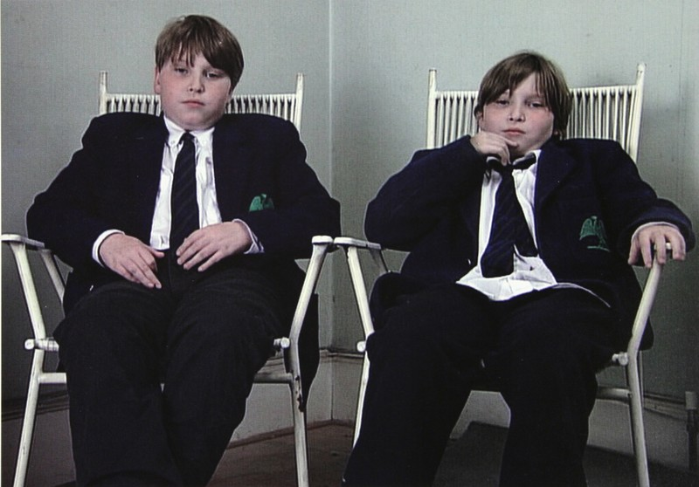Fig 1. Wearing, G (1997) 2 into 1. Projection with sound 4 minutes 30 seconds. © the artist Courtesy Maureen Paley, London

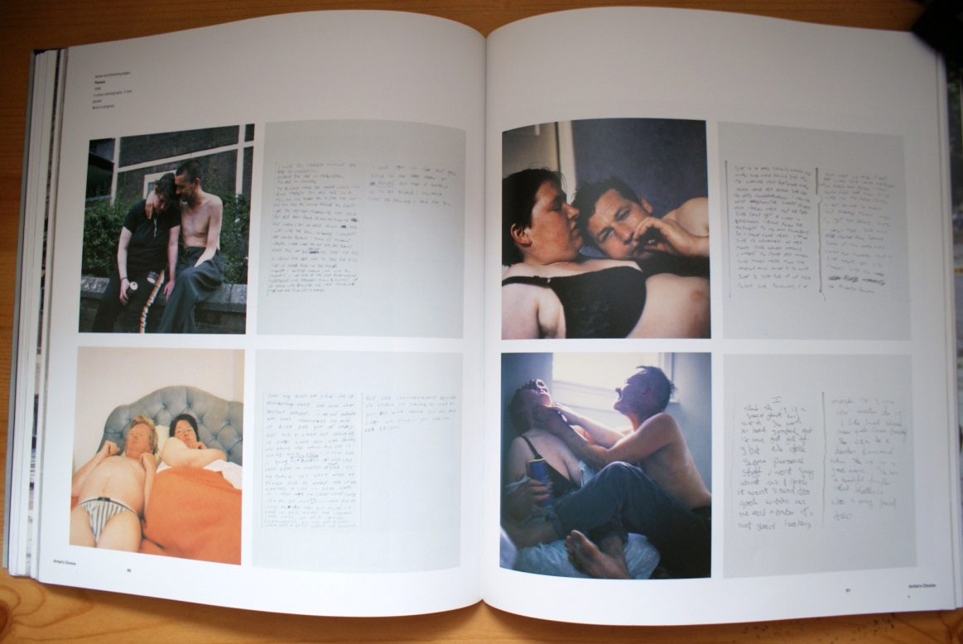
Fig 2.1. Wearing, G (1999) A Woman Called Theresa. Photographed from the book, Gillian Wearing (1999) Russell Ferguson, Donna De Salvo and John Slyce.
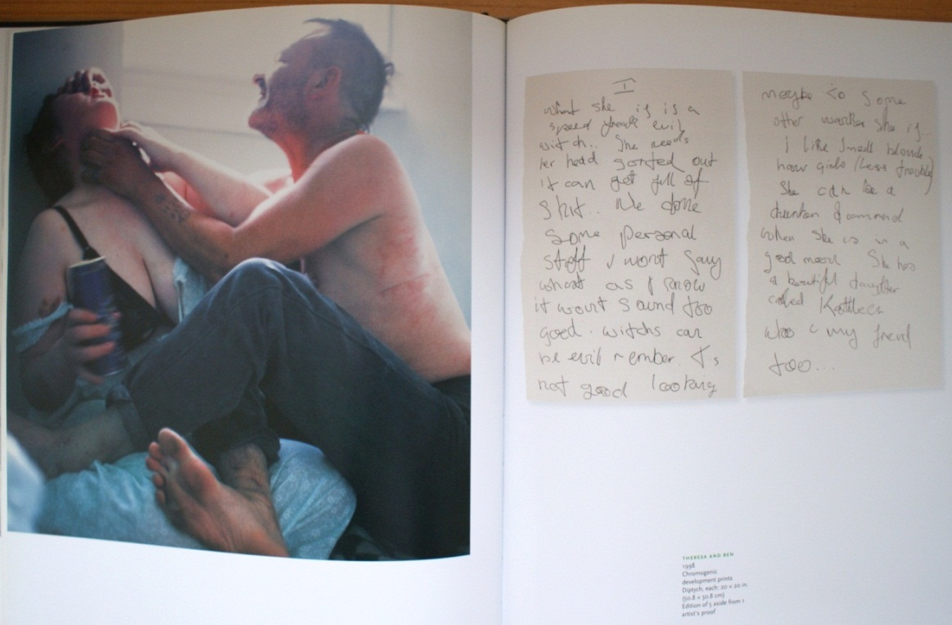 Fig 2.2. Wearing, G (1999) A Woman Called Theresa (Theresa with Ben). Photographed from the book, Gillian Wearing Russell Ferguson, Donna De Salvo and John Slyce.

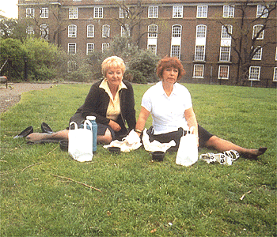
Fig 3.1.Wearing, G (1998) 10 – 16, (11). Single channel video. Tate. Presented by the Patrons of New Art through the Tate Gallery Foundation © the artist and Maureen Paley.

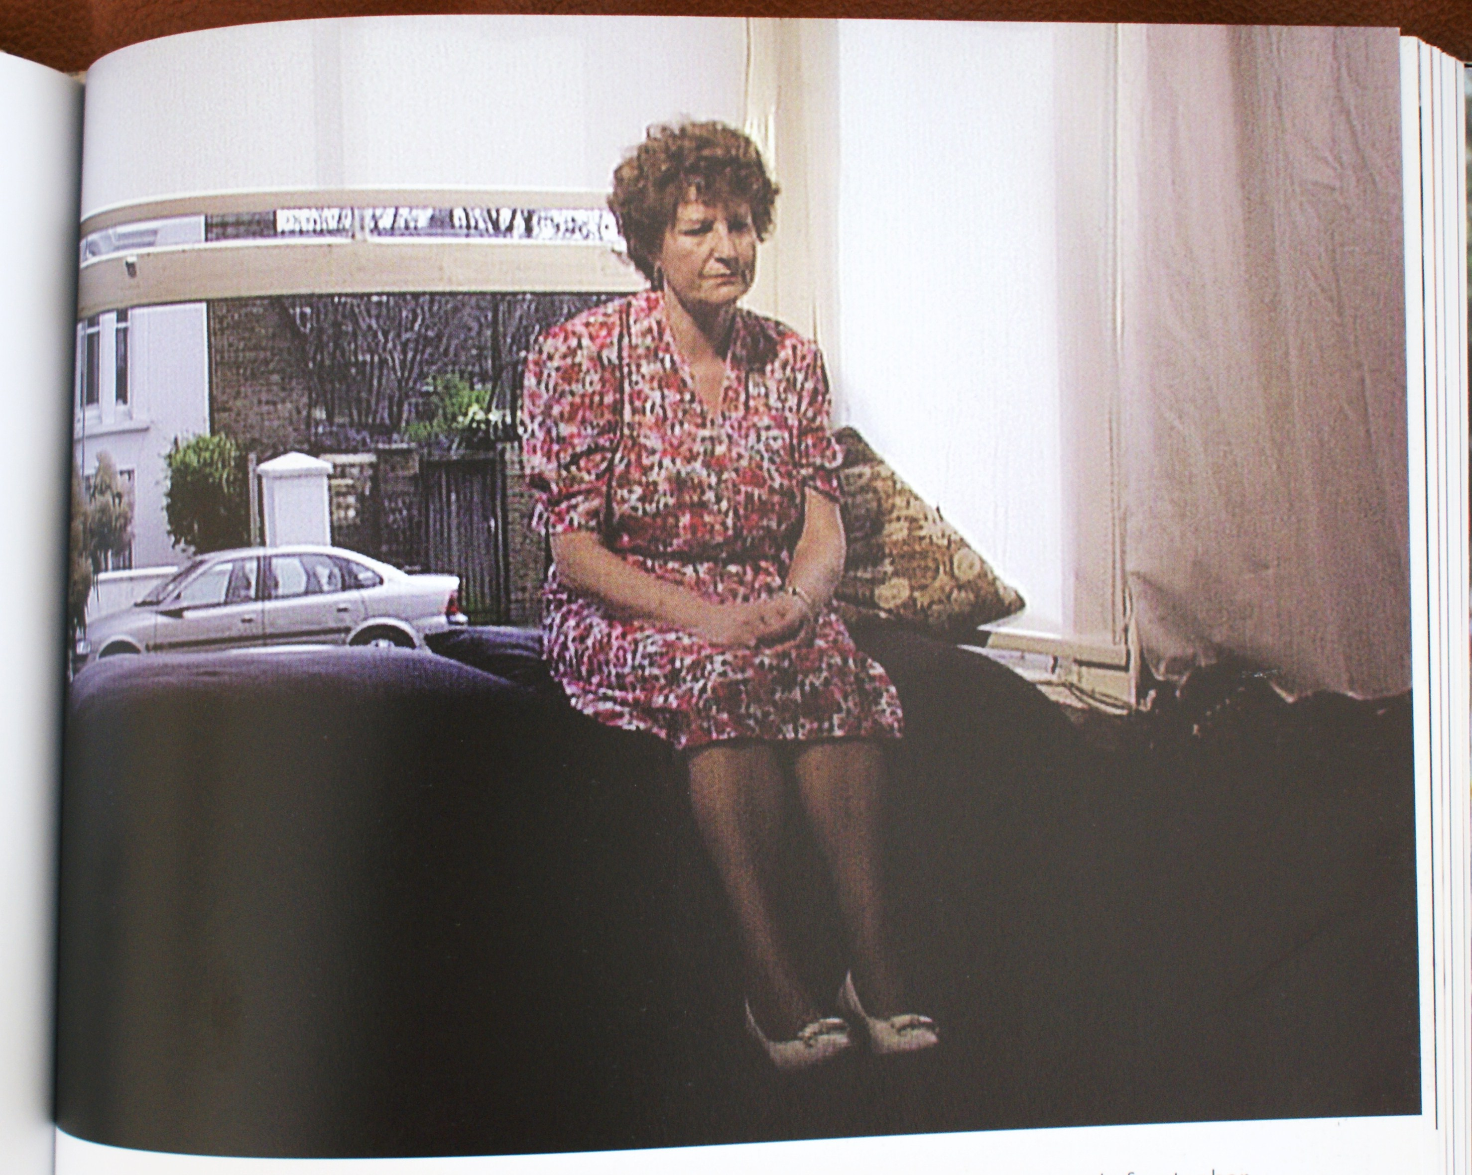Fig 3.2. Wearing,G (1997) 10-16, (12) Single channel video. Photograph taken of photograph in the book Gillian Wearing (1999:137) Russell Ferguson Donna De Salvo, John Slyce.

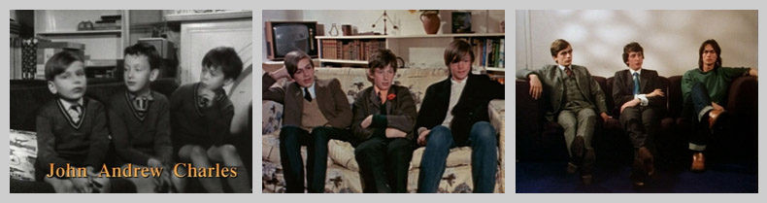
Fig 4. Apted, M (1964 onwards)The Up Series. Film stills of interviews with John,
Andrew and Charles at the ages 7, 14 and 21 from Ted Dejony’s Seven Up! series essay website: http://www.tdejony.com/grcp101/dejony_seven_up.html

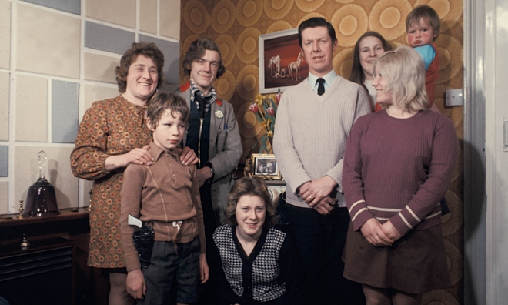
Fig 5. Watson, P (1974) The Family. Photograph from the TV Cream website: http://www.tvcream.co.uk/?p=2239

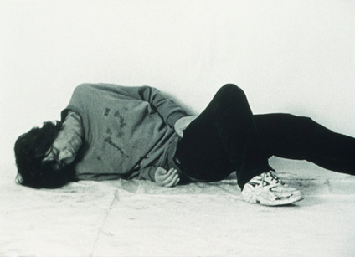
Fig 6. Wearing, G (1999) Drunk. DVD three screen projection 23 minutes. Maureen Paley, London.

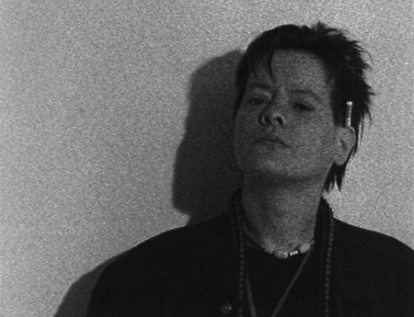
Fig 7. Wearing, G (2000) Prelude. DVD projection 10 minutes.

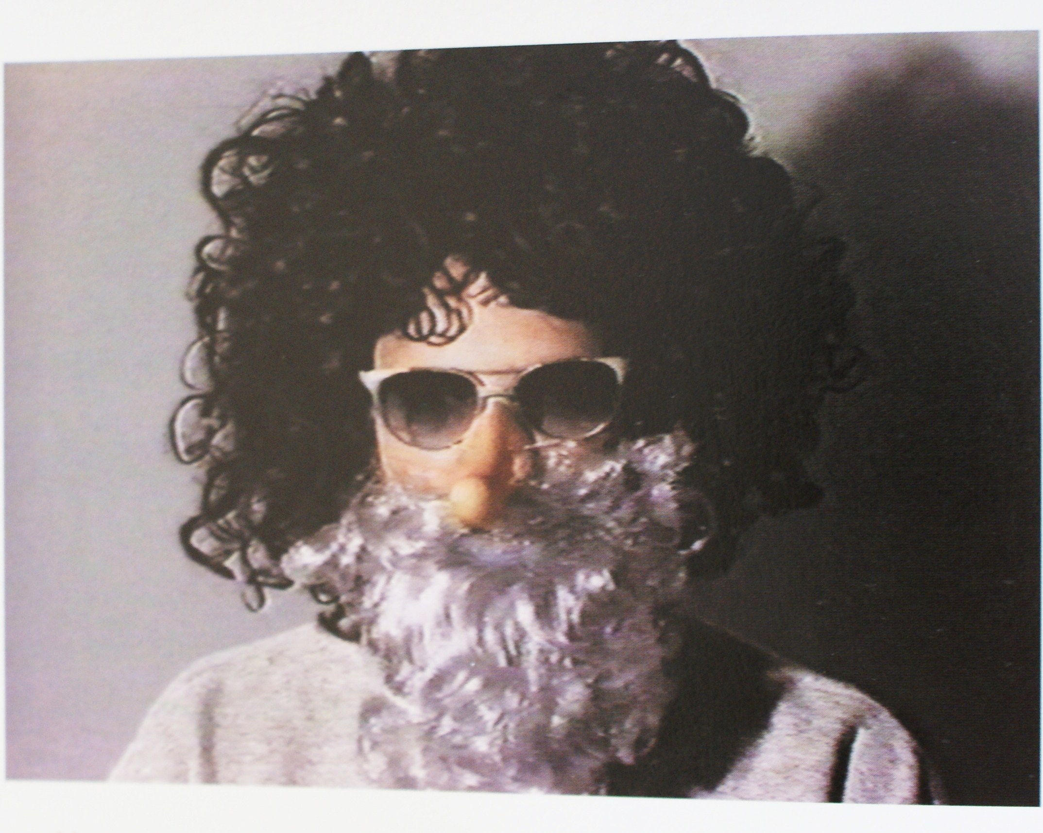
Fig 8.1 Wearing, G (1994) Confess All On Video. Don’t Worry, You Will Be In Disguise. Intrigued? Call Gillian…Colour video with sound 30 minutes.
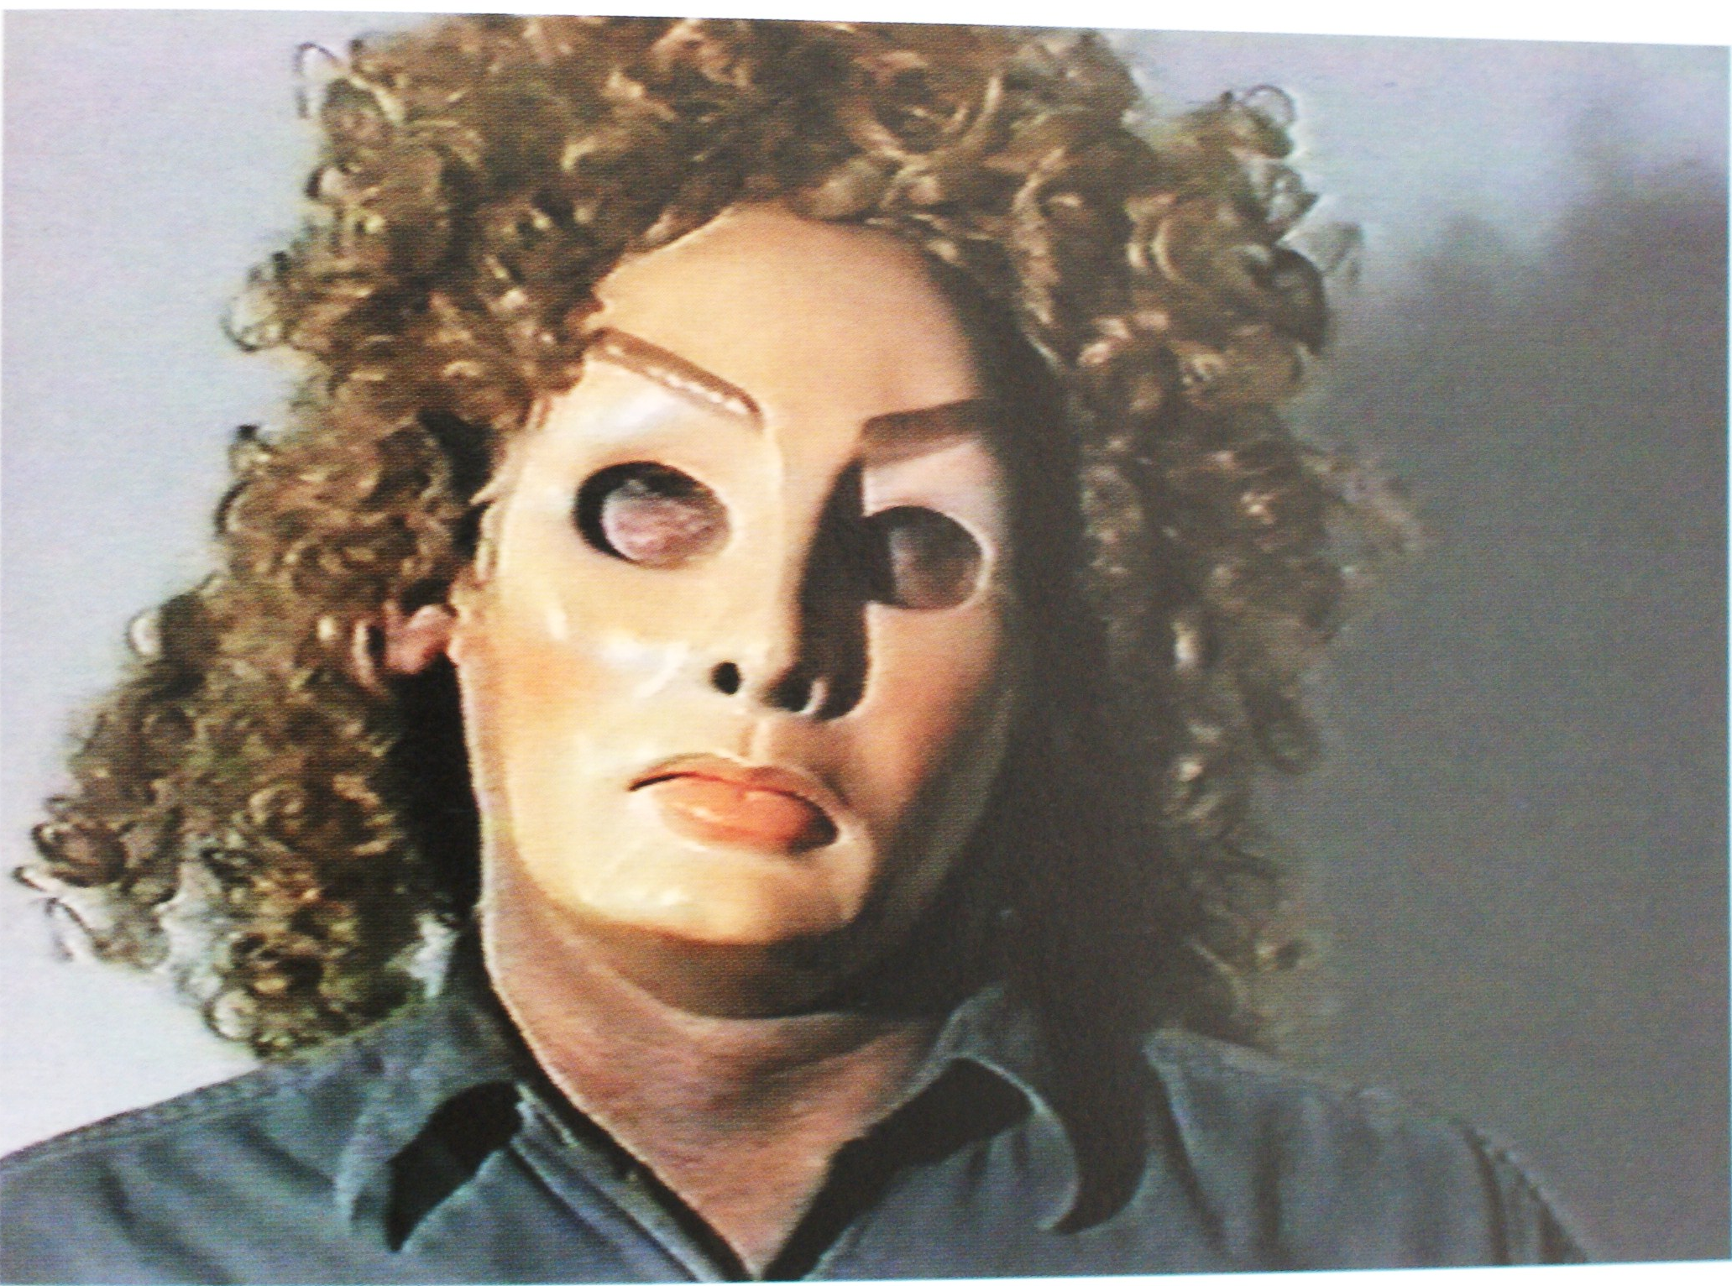Fig 8.2. Wearing, G (1994) Confess All On Video. Don’t Worry, You Will Be In Disguise. Intrigued? Call Gillian…Colour video with sound 30 minutes.

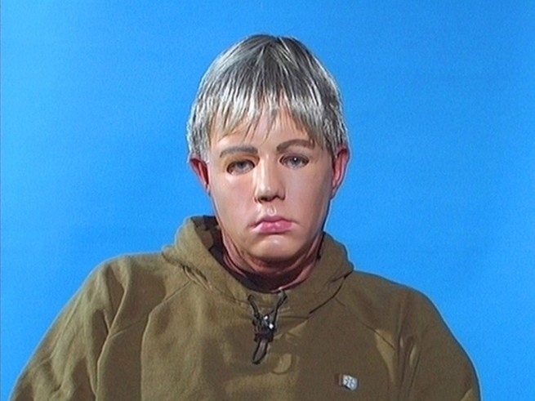
Fig 9. Wearing, G (2000) Trauma. Colour video for monitor with sound 30 minutes
© the artist. Courtesy Maureen Paley, London
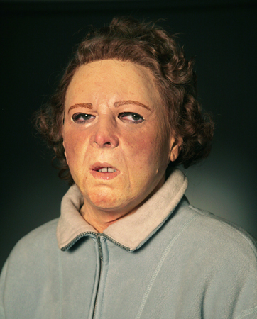
Fig 10. Wearing, G (2009) Secrets and Lies. Video for monitor with sound, 53 minutes, 16 seconds. Courtesy the artist and Tanya Bonakdar Gallery, New York.

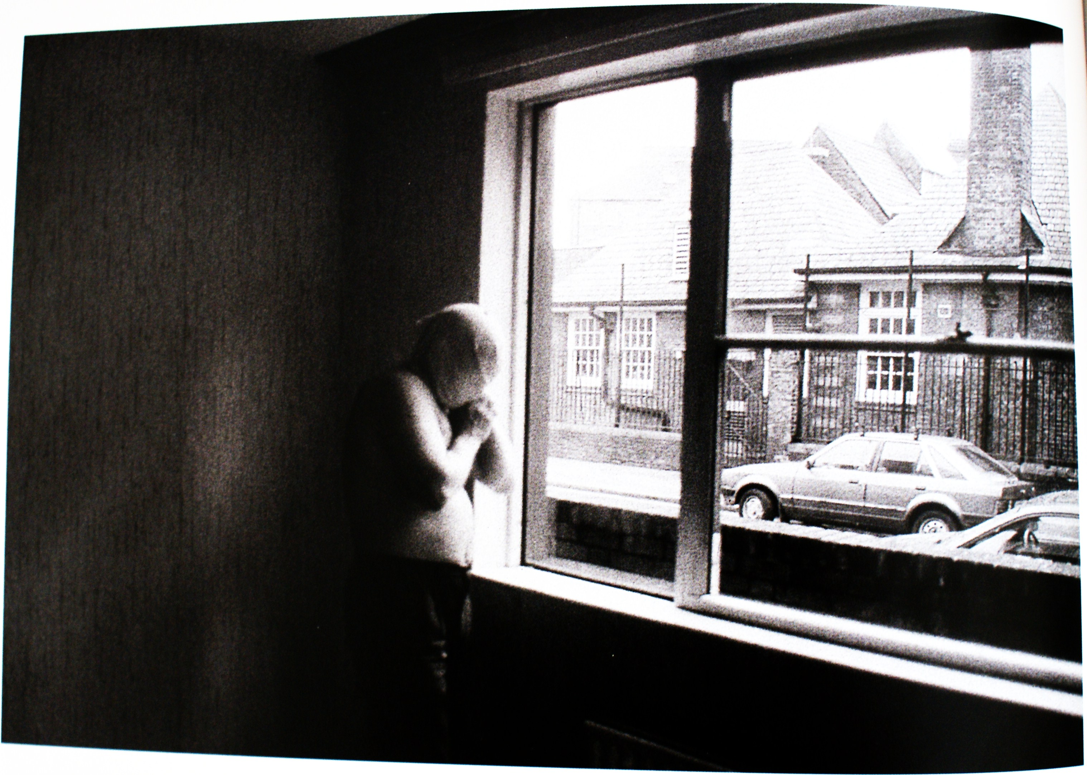Fig 11. Wearing, G (1996) Brian. Black and white photograph, Iris print text panel 90x124cm each. Photographed from the book Gillian Wearing (1999:58) Russell Ferguson Donna De Salvo, John Slyce.
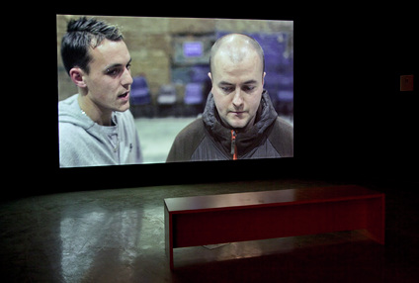
Fig 12. Wearing, G (2010) Bully. Video for projection with sound 7 minutes 55 seconds. © the artist. Courtesy Maureen Paley, London.


Fig 13. Wearing, G (2010) Self Made. Film, 84 minutes.

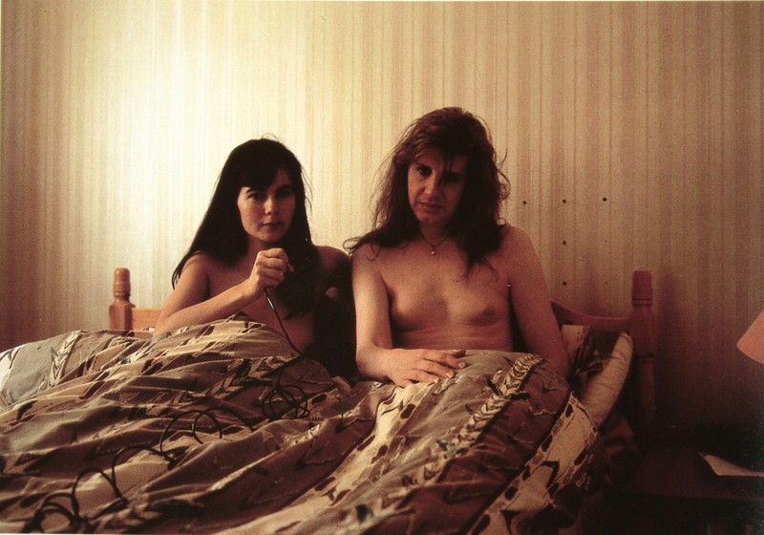
Fig 14. Wearing, G (1993) Take Your Top Off. Wearing, Gillian, Londres, Phaidon, (1999).

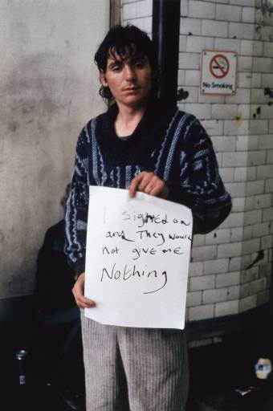
Fig 15. Wearing, G (1993) I signed on and they would not give me nothing, from Signs that Say What You Want Them To Say and Not Signs that Say What Someone Else Wants You To Say. Gillian Wearing, courtesy Maureen Paley/ Interim Art, London.
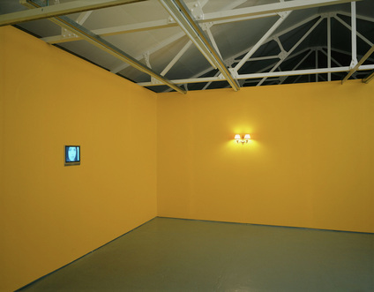
Fig 16.1. Wearing, G (2000) Family History. DVD for projection: 38 minutes 29 seconds. DVD for plasma monitor: 2 mins 56 secs. © the artist. Courtesy Maureen Paley, London.

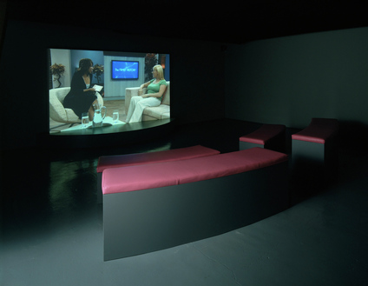Fig 16.2. Wearing, G (2000) Family History. DVD for projection: 38 minutes 29 seconds. DVD for plasma monitor: 2 mins 56 secs. © the artist. Courtesy Maureen Paley, London.
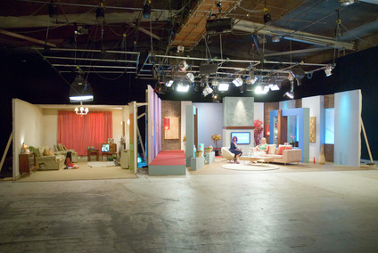
Fig 16.3. Wearing, G (2000) Family History. DVD for projection: 38 minutes 29 seconds. DVD for plasma monitor: 2 mins 56 secs. © the artist. Courtesy Maureen Paley, London.

